Group-Rubicx

ET2596 TASK-2

Rajnandini Bhutada Parthasarathy Singh Samanta

[rabh21@student.bth.se](mailto:rabh21@student.bth.se) [pasb21@student.bth.se](mailto:pasb21@student.bth.se)

Introduction:

In this report, we are going to discuss the results we have obtained from the ‘software’ given and answer the questions in TASK-2 of course ET2594.

Each of the questions of Task 2 is discussed in detail and according to the question needs few parameters are altered to note their effect while others are kept constant.

Both the team members worked and analysed all the questions together, for all questions there were arguments and conflicts between team members which was finally solved and joint conclusion was given for each question.

Each question has its own hypothesis which describes what we expect the output to look like followed by the tabular results and later explanation of our expected results in conclusions and on what we understood from the plot and tables. Consequently, all questions have different planning which is specified for each question in their respective sections, and for each question we change parameters and note their impact on other parameters.

The reference simulation parameters are taken as:

|  |  |  |  |
| --- | --- | --- | --- |
| Seed | E[Ta] | E[Ts] | Warm-up |
| 2002 | 100 | 80 | 1 |

|  |  |  |  |  |
| --- | --- | --- | --- | --- |
| Arrival | Server | Length of batches | Number of  arrivals per batch | Queue length |
| M | M | 200 | 100 | 5 |

We initially considered the M/M/1 model as it resonates more with real life scenarios.

Further, length of batches = 200 and the number of arrivals per batch = 100 are considered, because comparatively we got a lower Confidence-Interval. Queue Length is = 5 as it is neither completely full nor is less such that we are rejecting many incoming customers.

For the first few questions instead of considering the impact on all the parameters, we have only considered the impact on Load as we feel Load gives all the crucial data necessary to understand the system at any instant, and the rest of the parameters can be understood by seeing the value of Load.

Experimental Results:

**Question-1:** **Describe the impact of the number of batches on the estimation of the autocorrelation.**

*Hypothesis:* As number of batches increases it is expected for autocorrelation values to have an effect and to increase.

Autocorrelation tells us about the similarity of the data, and it is counterparts and can tell us about the randomness of the data. In this, we have considered the load parameter for performing autocorrelation of 8 different simulations, because load parameter tend to have significant effect for the number of batches keeping all the other parameters constant. Autocorrelation is done for 8 distinct values of no. of batches:

|  |  |  |
| --- | --- | --- |
| System | Number of batches | Number of arrivals |
| M/M/1 | 50 | 100 |
| M/M/1 | 100 | 100 |
| M/M/1 | 200 | 100 |
| M/M/1 | 500 | 100 |
| M/M/1 | 700 | 100 |
| M/M/1 | 1000 | 100 |
| M/M/1 | 5000 | 100 |
| M/M/1 | 10000 | 100 |

Table 1.1

Simulated lag-1 autocorrelation for each of the batches are as follows:

|  |  |
| --- | --- |
| Number of batches | Lag-1 Autocorrelation |
| 50 | -0.0029 |
| 100 | -0.0436 |
| 200 | 0.0583 |
| 500 | 0.0304 |
| 700 | 0.0152 |
| 1000 | 0.0317 |
| 5000 | 0.0200 |
| 10000 | 0.0100 |

Table 1.2

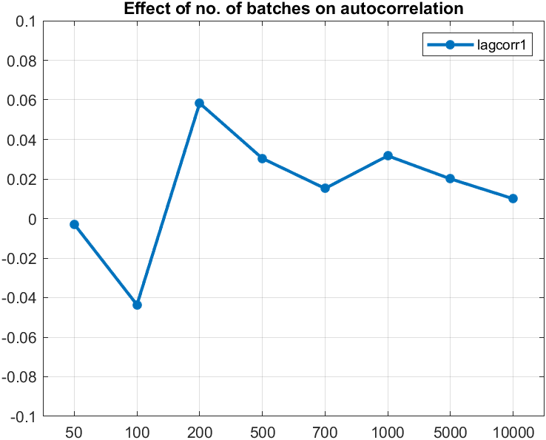

Figure 1

The above Figure 1 shows the autocorrelation of load as we have considered load values to be a very important result as it talks about the condition or state of the system at that batch while other parameters like loss ratio and queuing ratio only focus on the number of people rejected in the queue or number of people in the queue. If we see the effect on load, we can know about the other parameters also.

*Conclusion:* From Figure 1 we can see that auto-correlation (lag-1) values are very low showing very less similarity between the data set and its shifted self. Since values are very small, one can say that varying the number of batches does not have any significant impact on autocorrelation, which also indicates that there is more dissimilarity and randomness in the dataset.

**Question 2:** Describe the impact of the length of the batches on the estimation of the autocorrelation.

*Hypothesis:* With increase in length of the batch’s autocorrelation is supposed to increase as variance among the samples tends to decrease.

Autocorrelation tells us about the similarity of the data, and it is counterparts and can tell us about the randomness of the data. We have considered 7 different lengths of batches for this experiment:

|  |  |  |
| --- | --- | --- |
| System | Number of batches | Number of Arrivals |
| M/M/1 | 200 | 50 |
| M/M/1 | 200 | 100 |
| M/M/1 | 200 | 200 |
| M/M/1 | 200 | 500 |
| M/M/1 | 200 | 1000 |
| M/M/1 | 200 | 5000 |
| M/M/1 | 200 | 10000 |

Table 2.1

The respective lag-1 autocorrelation for length of batches is:

|  |  |
| --- | --- |
| Number of Arrivals | Lag-1 Autocorrelation |
| 50 | 0.0238 |
| 100 | 0.0583 |
| 200 | 0.0179 |
| 500 | 0.0281 |
| 1000 | -0.0807 |
| 5000 | -0.0367 |
| 10000 | -0.0013 |

Table 2.2

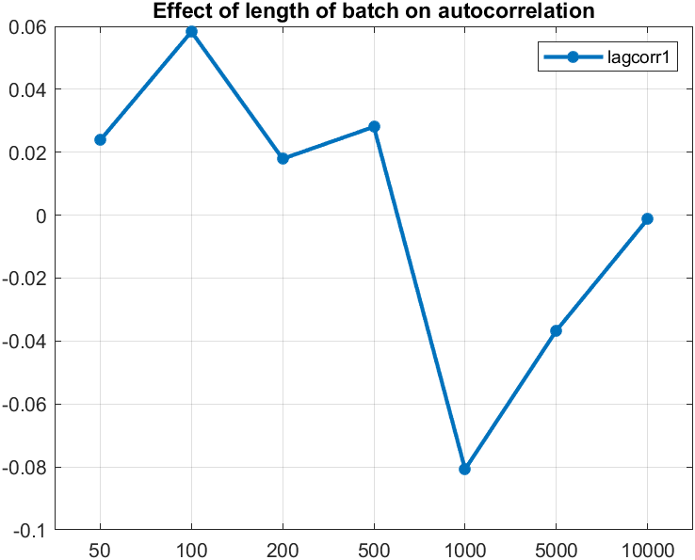

Figure 2

To determine the impact of the length of batches, load values are selected as a parameter to describe the effect of changes in length of batches for autocorrelation.

*Conclusion:* From Figure 2 we can conclude that the values of lag-1 auto-correlation are varying slightly but, these values are very small and are not changing drastically. Hence, we can say that there is not much effect of the increase in the number of arrivals/length of batches on autocorrelation, which also indicates that there is more dissimilarity and randomness in the dataset.

**Question-3:** Describe the impact of the number of batches on the size of the confidence intervals.

*Hypothesis:* With increase in number of batches the Confidence intervals are supposed to decrease.

To give a better analysis we have simulated 8 different batches to know their impact on the size of the confidence interval (90% CI, 95% CI & 99% CI).

|  |  |  |
| --- | --- | --- |
| System | Number of batches | Number of arrivals |
| M/M/1 | 50 | 100 |
| M/M/1 | 100 | 100 |
| M/M/1 | 200 | 100 |
| M/M/1 | 500 | 100 |
| M/M/1 | 700 | 100 |
| M/M/1 | 1000 | 100 |
| M/M/1 | 5000 | 100 |
| M/M/1 | 10000 | 100 |

# Table 3.1

Their responding confidence interval values are:

|  |  |  |  |  |
| --- | --- | --- | --- | --- |
| Number of batches | Mean | 90% CI | 95% CI | 99% CI |
| 50 | 0.7558 | 0.0357 | 0.0428 | 0.0571 |
| 100 | 0.7510 | 0.0278 | 0.0332 | 0.0440 |
| 200 | 0.7454 | 0.0199 | 0.0237 | 0.0313 |
| 500 | 0.7516 | 0.0188 | 0.0140 | 0.0185 |
| 700 | 0.7542 | 0.0100 | 0.0120 | 0.0158 |
| 1000 | 0.7500 | 0.0085 | 0.0101 | 0.0133 |
| 5000 | 0.7514 | 0.0038 | 0.0045 | 0.0059 |
| 10000 | 0.0519 | 0.0027 | 0.0032 | 0.0042 |

Table 3.2

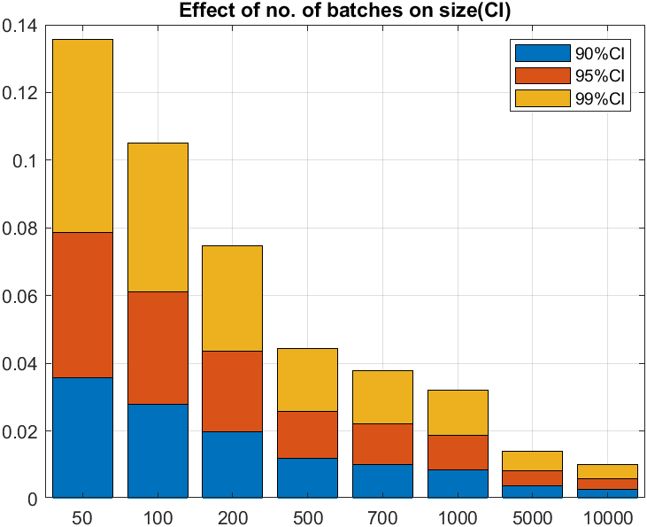

# Figure 3

We already know that formula of CI is

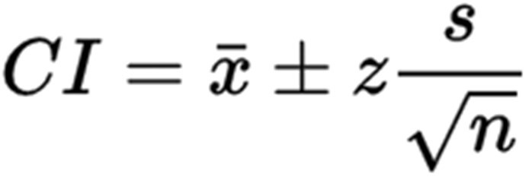

Where ‘n’ represents the sample size and as the ‘n’ increases the value of interval will decrease which is exactly shown in the Figure 3.

*Conclusion:* From above Figure 3 we can see confidence interval for all batches at three different CI sizes and it can be concluded that increase in the length of batches decreases the confidence interval for all values i.e., our hypothesis is correct. Hence, the above formula is also validated.

**Question 4:** Describe the impact of the length of the batches on the size of the confidence intervals.

*Hypothesis:* With increase in length of batches size of confidence intervals is expected to decrease.

For a better understanding of the effect of batch length on the confidence interval of mean load values in each batch, we have simulated 7 different lengths of batches and have calculated for 3 different intervals those are: 90% CI, 95% CI, and 99% CI.

|  |  |  |
| --- | --- | --- |
| System | Number of batches | Number of Arrivals |
| M/M/1 | 200 | 50 |
| M/M/1 | 200 | 100 |
| M/M/1 | 200 | 200 |
| M/M/1 | 200 | 500 |
| M/M/1 | 200 | 1000 |
| M/M/1 | 200 | 5000 |
| M/M/1 | 200 | 10000 |

Table 4.1

After simulation there corresponding Confidence interval values are:

|  |  |  |  |  |
| --- | --- | --- | --- | --- |
| length of batches | Mean | 90% CI | 95% CI | 99% CI |
| 50 | 0.7551 | 0.0261 | 0.0311 | 0.0410 |
| 100 | 0.7454 | 0.0199 | 0.0237 | 0.0313 |
| 200 | 0.7497 | 0.0136 | 0.0162 | 0.0214 |
| 500 | 0.7457 | 0.0091 | 0.0109 | 0.0144 |
| 1000 | 0.7478 | 0.0062 | 0.0074 | 0.0098 |
| 5000 | 0.7467 | 0.0026 | 0.0031 | 0.0041 |
| 10000 | 0.7471 | 0.0019 | 0.0023 | 0.0030 |

Table 4.2

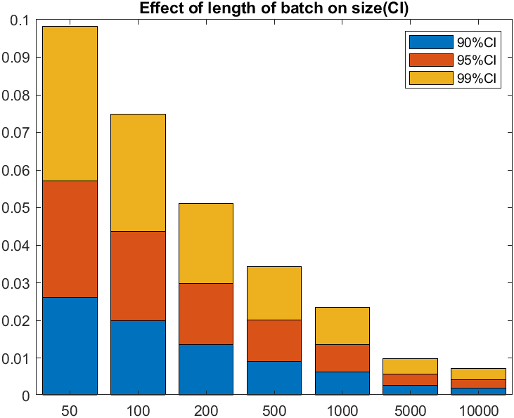

Figure 4

*Conclusion:* From above Figure 4, we can conclude that although the values of the confidence intervals are very small as the length increases there is a gradual decrease in the interval of the confidence interval. Hence, this indicates our hypothesis is correct.

This is further validated by the property of confidence interval when the sample size is increased, i.e., when that happens, we say that standard error decreases and hence there is less variation in samples which results in decreasing the confidence interval.

**Question 5:** Discuss the impact of the average service time on load, loss ratio, and queuing ratio.

Hypothesis: As the service time increases it is assumed that load, loss ratio and queuing ratio also increases.

To know about the impact of load, loss ratio and queuing ratio we have varied both service times and queue length. We have considered 6 different Service time and 2 different queue lengths. We have considered to vary queue length as by varying them we can see impact on loss ratio and queuing ratio.

The simulated parameters are as follows:

|  |  |  |  |
| --- | --- | --- | --- |
| System | Queue Length | E[Ta] | E[Ts] |
| M/M/1 | 5 | 100 | 40 |
| M/M/1 | 5 | 100 | 60 |
| M/M/1 | 5 | 100 | 80 |
| M/M/1 | 5 | 100 | 100 |
| M/M/1 | 5 | 100 | 120 |
| M/M/1 | 5 | 100 | 150 |

Table 5.1

|  |  |  |  |
| --- | --- | --- | --- |
| System | Queue Length | E[Ta] | E[Ts] |
| M/M/1 | 10 | 100 | 40 |
| M/M/1 | 10 | 100 | 60 |
| M/M/1 | 10 | 100 | 80 |
| M/M/1 | 10 | 100 | 100 |
| M/M/1 | 10 | 100 | 120 |
| M/M/1 | 10 | 100 | 150 |

Table 5.2

After simulation we find mean of all the values to know their impact on corresponding service time and queue length, results obtained are as follows:

|  |  |  |  |  |
| --- | --- | --- | --- | --- |
| E[Ts] | Queue Length | Load | Loss Ratio | Queueing Ratio |
| 40 | 5 | 0.392 | 0.0021 | 0.3866 |
| 60 | 5 | 0.598 | 0.0232 | 0.5695 |
| 80 | 5 | 0.7454 | 0.0636 | 0.6776 |
| 100 | 5 | 0.8552 | 0.1440 | 0.7058 |
| 120 | 5 | 0.9193 | 0.2226 | 0.6956 |
| 150 | 5 | 0.9722 | 0.3490 | 0.6217 |

Table 5.3

|  |  |  |  |  |
| --- | --- | --- | --- | --- |
| E[Ts] | Queue Length | Load | Loss Ratio | Queueing Ratio |
| 40 | 10 | 0.4002 | 0 | 0.3940 |
| 60 | 10 | 0.6088 | 0.0012 | 0.6044 |
| 80 | 10 | 0.7879 | 0.0167 | 0.7598 |
| 100 | 10 | 0.9144 | 0.0856 | 0.8269 |
| 120 | 10 | 0.9804 | 0.1826 | 0.7961 |
| 150 | 10 | 0.9974 | 0.3381 | 0.6591 |

Table 5.4

For queue-length = 5 varying service-time plot is as followed:

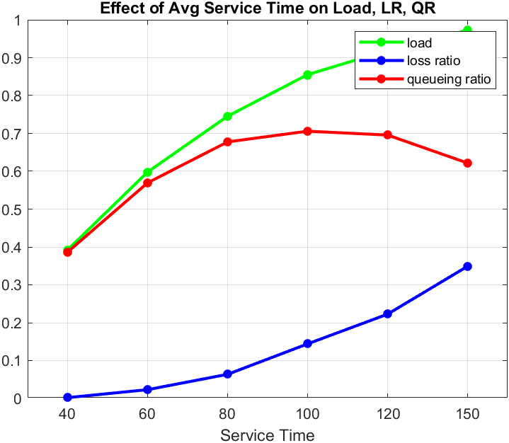

Figure 5.1

For queue-length = 10 varying service-time plot is as followed:

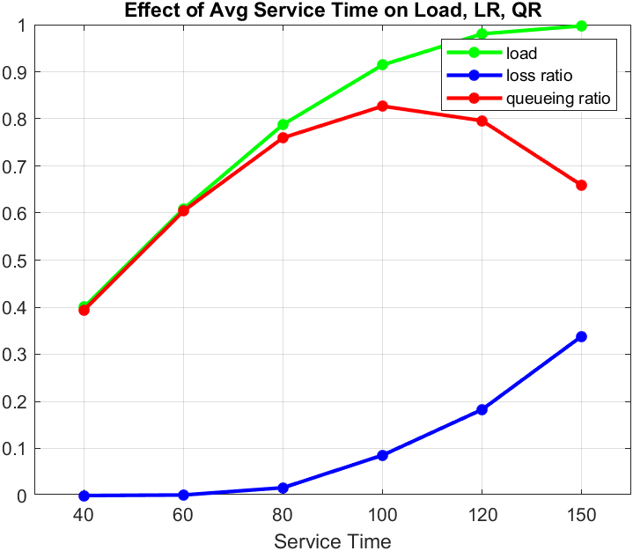

Figure 5.2

*Conclusion:* From Figure 5.1 and Figure 5.2 we can see that as service time increases loss ratio and load increases even if the system service-time is more than its full potential. But in case of queuing ratio, we can see that after service-time = 100, there is a decrease in queuing ratio.

**Question 6:** Discuss the impact of the average service time on the size of the confidence intervals.

*Hypothesis:* As service time increases load, loss ratio and queuing ratio are expected to increase and size of confidence intervals is expected to decrease.

In this question we are simulating for queue-length = 5 and 10 to see any effect on loss ratio and queuing ratio.

|  |  |  |  |
| --- | --- | --- | --- |
| System | Queue length | E[Ta] | E[Ts] |
| M/M/1 | 5 | 100 | 40 |
| M/M/1 | 5 | 100 | 60 |
| M/M/1 | 5 | 100 | 80 |
| M/M/1 | 5 | 100 | 100 |
| M/M/1 | 5 | 100 | 120 |
| M/M/1 | 5 | 100 | 150 |

Table 6.1

|  |  |  |  |
| --- | --- | --- | --- |
| System | Queue Length | E[Ta] | E[Ts] |
| M/M/1 | 10 | 100 | 40 |
| M/M/1 | 10 | 100 | 60 |
| M/M/1 | 10 | 100 | 80 |
| M/M/1 | 10 | 100 | 100 |
| M/M/1 | 10 | 100 | 120 |
| M/M/1 | 10 | 100 | 150 |

Table 6.2

The obtained confidence intervals for various service time and queue lengths are:

|  |  |  |  |  |  |  |  |  |  |  |
| --- | --- | --- | --- | --- | --- | --- | --- | --- | --- | --- |
| E[Ts] | Queue Length | Load | | | Loss Ratio | | | Queueing Ratio | | |
| 90 | 95 | 99 | 90 | 95 | 99 | 90 | 95 | 99 |
| 40 | 5 | 0.012 | 0.015 | 0.019 | 0.001 | 0.002 | 0.002 | 0.016 | 0.019 | 0.025 |
| 60 | 5 | 0.018 | 0.021 | 0.028 | 0.006 | 0.007 | 0.009 | 0.019 | 0.022 | 0.030 |
| 80 | 5 | 0.019 | 0.023 | 0.031 | 0.012 | 0.014 | 0.019 | 0.016 | 0.019 | 0.025 |
| 100 | 5 | 0.017 | 0.020 | 0.027 | 0.017 | 0.020 | 0.027 | 0.015 | 0.018 | 0.024 |
| 120 | 5 | 0.012 | 0.015 | 0.019 | 0.018 | 0.021 | 0.028 | 0.014 | 0.017 | 0.022 |
| 150 | 5 | 0.007 | 0.008 | 0.011 | 0.020 | 0.024 | 0.031 | 0.017 | 0.021 | 0.028 |

Table 6.3

|  |  |  |  |  |  |  |  |  |  |  |
| --- | --- | --- | --- | --- | --- | --- | --- | --- | --- | --- |
| E[Ts] | Queue Length | Load | | | Loss Ratio | | | Queueing Ratio | | |
| 90 | 95 | 99 | 90 | 95 | 99 | 90 | 95 | 99 |
| 40 | 10 | 0.021 | 0.015 | 0.021 | 0 | 0 | 0 | 0.016 | 0.019 | 0.025 |
| 60 | 10 | 0.031 | 0.023 | 0.031 | 0.001 | 0.001 | 0.001 | 0.021 | 0.025 | 0.033 |
| 80 | 10 | 0.037 | 0.028 | 0.037 | 0.007 | 0.009 | 0.012 | 0.023 | 0.027 | 0.036 |
| 100 | 10 | 0.024 | 0.018 | 0.024 | 0.017 | 0.020 | 0.027 | 0.015 | 0.018 | 0.024 |
| 120 | 10 | 0.012 | 0.009 | 0.012 | 0.021 | 0.026 | 0.034 | 0.019 | 0.023 | 0.030 |
| 150 | 10 | 0.003 | 0.002 | 0.003 | 0.022 | 0.026 | 0.035 | 0.021 | 0.025 | 0.033 |

Table 6.4

For queue-length = 5 and CI = 95 the graph looks like:

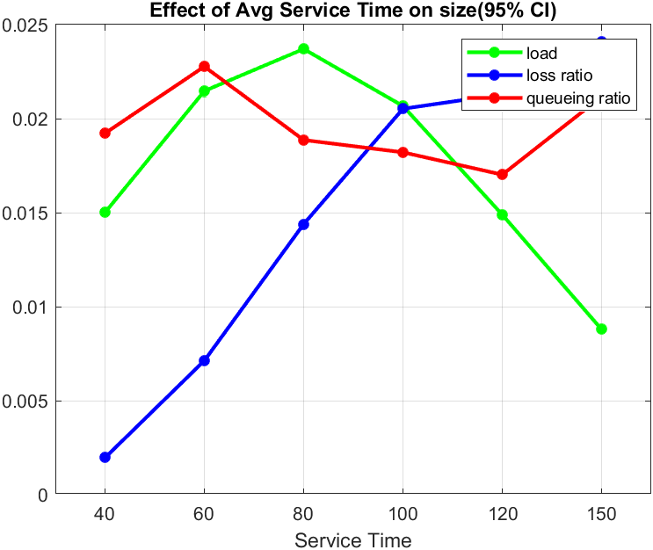

Figure 6.1

For queue-length = 10 and CI = 95 the graph looks like:

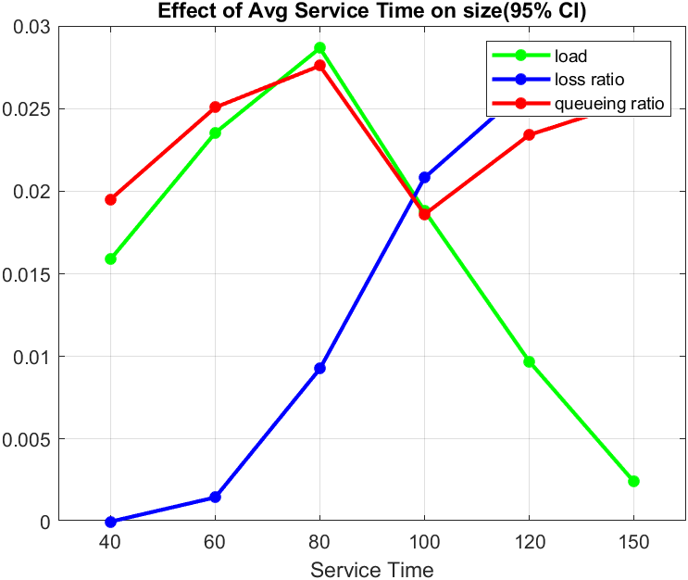

Figure 6.2

*Conclusion:* From above Figure 6.1 and Figure 6.2, we can say that as the service time increases then the loss ratio decreases, and hence the confidence interval size of the loss ratio increases. But for load and queuing ratio they are supposed to increase and confidence interval is also expected to increase but we can’t say anything about effect of service time on confidence interval from the above graphs. We cannot understand in the cases where the system is pushed to work more than 100% i.e., when service-time is more than 100 why the confidence interval is increasing or decreasing. We can conclude that for less service time we will get more precision in case of loss ratio.

**Question 7:** Comment on the impact of the size of the loss ratio on the absolute sizes of the confidence intervals.

*Hypothesis:* It is assumed that by varying service-time and queue-length loss ratio must increase and absolute sizes of confidence intervals must also increase.

As we know that loss ratio is the number of customers rejected when they are trying to enter the system. The only reason people will be rejected is when the queue size is filled such that there is no space for the next arriving customer.

We have simulated 6 different service-times and 3 different queue-lengths to know their impact on the size of the confidence interval:

|  |  |  |  |
| --- | --- | --- | --- |
| System | Queue length | E[Ta] | E[Ts] |
| M/M/1 | 2 | 100 | 40 |
| M/M/1 | 2 | 100 | 60 |
| M/M/1 | 2 | 100 | 80 |
| M/M/1 | 2 | 100 | 100 |
| M/M/1 | 2 | 100 | 120 |
| M/M/1 | 2 | 100 | 150 |

Table 7.1

|  |  |  |  |
| --- | --- | --- | --- |
| System | Queue Length | E[Ta] | E[Ts] |
| M/M/1 | 5 | 100 | 40 |
| M/M/1 | 5 | 100 | 60 |
| M/M/1 | 5 | 100 | 80 |
| M/M/1 | 5 | 100 | 100 |
| M/M/1 | 5 | 100 | 120 |
| M/M/1 | 5 | 100 | 150 |

Table 7.2

|  |  |  |  |
| --- | --- | --- | --- |
| System | Queue Length | E[Ta] | E[Ts] |
| M/M/1 | 10 | 100 | 40 |
| M/M/1 | 10 | 100 | 60 |
| M/M/1 | 10 | 100 | 80 |
| M/M/1 | 10 | 100 | 100 |
| M/M/1 | 10 | 100 | 120 |
| M/M/1 | 10 | 100 | 150 |

Table 7.3

The table for 3 different queue-lengths and varying service-time are as follows:

|  |  |  |  |  |  |
| --- | --- | --- | --- | --- | --- |
| Service time | Queue-length | Mean | Abs 90% CI | Abs 95% CI | Abs 99% CI |
| 40 | 2 | 0.036 | 0.0028 | 0.0033 | 0.0044 |
| 60 | 2 | 0.103 | 0.0052 | 0.0062 | 0.0082 |
| 80 | 2 | 0.1782 | 0.0068 | 0.0081 | 0.0107 |
| 100 | 2 | 0.251 | 0.0076 | 0.0090 | 0.0119 |
| 120 | 2 | 0.328 | 0.0078 | 0.0093 | 0.0123 |
| 150 | 2 | 0.423 | 0.0081 | 0.0097 | 0.0128 |

Table 7.4

|  |  |  |  |  |  |
| --- | --- | --- | --- | --- | --- |
| Service time | Queue-length | Mean | Abs 90% CI | Abs 95% CI | Abs 99% CI |
| 40 | 5 | 0.0021 | 0.0008 | 0.0010 | 0.0013 |
| 60 | 5 | 0.0232 | 0.0030 | 0.0036 | 0.0047 |
| 80 | 5 | 0.0636 | 0.0060 | 0.0072 | 0.0095 |
| 100 | 5 | 0.1440 | 0.0086 | 0.0103 | 0.0135 |
| 120 | 5 | 0.226 | 0.0089 | 0.0106 | 0.0140 |
| 150 | 5 | 0.349 | 0.0101 | 0.0120 | 0.0159 |

Table 7.5

|  |  |  |  |  |  |
| --- | --- | --- | --- | --- | --- |
| Service time | Queue-length | Mean | Abs 90% CI | Abs 95% CI | Abs 99% CI |
| 40 | 10 | 0 | 0 | 0 | 0 |
| 60 | 10 | 0.0012 | 0.0006 | 0.0007 | 0.0010 |
| 80 | 10 | 0.0167 | 0.0039 | 0.0046 | 0.0061 |
| 100 | 10 | 0.0856 | 0.0087 | 0.0104 | 0.0137 |
| 120 | 10 | 0.1826 | 0.0111 | 0.0132 | 0.0174 |
| 150 | 10 | 0.3381 | 0.0111 | 0.0132 | 0.0174 |

Table 7.6

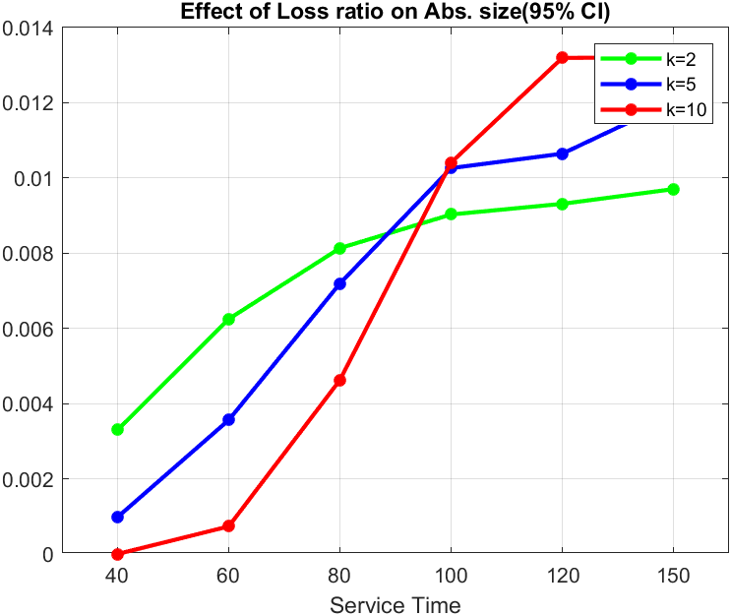

Figure 7

*Conclusion:* From above Figure 7, we can say that as the service time increases the absolute confidence interval increases indicating that there are more chances of loss since, the customers coming will have to spend more time in the queue and few of the customers can even be rejected if the queue is full, which can be seen from the simulation shown in class [1]. In addition, we can also see that when queue length is less the absolute confidence-interval is more compared to when queue length is more for underload condition and exactly opposite happens for overload case.

**Question 8:** Comment on the impact of the size of the load or queuing ratio on the absolute sizes of the confidence intervals.

*Hypothesis:* As service-time and queue-length increases effect on absolute sizes of confidence interval of load and queuing ratio are supposed to increase.

We have simulated 6 different service-times and 3 different queue-lengths to know their impact on the size of the confidence interval:

|  |  |  |  |
| --- | --- | --- | --- |
| System | Queue length | E[Ta] | E[Ts] |
| M/M/1 | 2 | 100 | 40 |
| M/M/1 | 2 | 100 | 60 |
| M/M/1 | 2 | 100 | 80 |
| M/M/1 | 2 | 100 | 100 |
| M/M/1 | 2 | 100 | 120 |
| M/M/1 | 2 | 100 | 150 |

Table 8.1

|  |  |  |  |
| --- | --- | --- | --- |
| System | Queue Length | E[Ta] | E[Ts] |
| M/M/1 | 5 | 100 | 40 |
| M/M/1 | 5 | 100 | 60 |
| M/M/1 | 5 | 100 | 80 |
| M/M/1 | 5 | 100 | 100 |
| M/M/1 | 5 | 100 | 120 |
| M/M/1 | 5 | 100 | 150 |

Table 8.2

|  |  |  |  |
| --- | --- | --- | --- |
| System | Queue Length | E[Ta] | E[Ts] |
| M/M/1 | 10 | 100 | 40 |
| M/M/1 | 10 | 100 | 60 |
| M/M/1 | 10 | 100 | 80 |
| M/M/1 | 10 | 100 | 100 |
| M/M/1 | 10 | 100 | 120 |
| M/M/1 | 10 | 100 | 150 |

Table 8.3

The following results have been obtained upon the simulation:

1. Impact of the absolute confidence interval on load by varying service time:

|  |  |  |  |  |  |
| --- | --- | --- | --- | --- | --- |
| Service time | Queue-length | Mean | Abs 90% CI | Abs 95% CI | Abs 99% CI |
| 40 | 2 | 0.3826 | 0.0053 | 0.0063 | 0.0084 |
| 60 | 2 | 0.5463 | 0.0073 | 0.0088 | 0.0116 |
| 80 | 2 | 0.6720 | 0.0082 | 0.0098 | 0.0129 |
| 100 | 2 | 0.7558 | 0.0081 | 0.0096 | 0.0127 |
| 120 | 2 | 0.8236 | 0.0073 | 0.0087 | 0.0114 |
| 150 | 2 | 0.8832 | 0.0059 | 0.0070 | 0.0092 |

Table 8.4

|  |  |  |  |  |  |
| --- | --- | --- | --- | --- | --- |
| Service time | Queue-length | Mean | Abs 90% CI | Abs 95% CI | Abs 99% CI |
| 40 | 5 | 0.3925 | 0.0063 | 0.0075 | 0.0099 |
| 60 | 5 | 0.5980 | 0.0090 | 0.0107 | 0.0142 |
| 80 | 5 | 0.7454 | 0.0099 | 0.0119 | 0.0156 |
| 100 | 5 | 0.8552 | 0.0087 | 0.0103 | 0.0136 |
| 120 | 5 | 0.9193 | 0.0062 | 0.0074 | 0.0098 |
| 150 | 5 | 0.9722 | 0.0037 | 0.0044 | 0.0058 |

Table 8.5

|  |  |  |  |  |  |
| --- | --- | --- | --- | --- | --- |
| Service time | Queue-length | Mean | Abs 90% CI | Abs 95% CI | Abs 99% CI |
| 40 | 10 | 0.4002 | 0.0067 | 0.0079 | 0.0105 |
| 60 | 10 | 0.6088 | 0.0099 | 0.0118 | 0.0155 |
| 80 | 10 | 0.7879 | 0.0120 | 0.0143 | 0.0189 |
| 100 | 10 | 0.9144 | 0.0079 | 0.0094 | 0.0124 |
| 120 | 10 | 0.9804 | 0.0041 | 0.0048 | 0.0064 |
| 150 | 10 | 0.9974 | 0.0010 | 0.0012 | 0.0016 |

Table 8.6

1. Impact of the absolute confidence interval on queueing ratio by varying service time:

|  |  |  |  |  |  |
| --- | --- | --- | --- | --- | --- |
| Service time | Queue-length | Mean | Abs 90% CI | Abs 95% CI | Abs 99% CI |
| 40 | 2 | 0.3418 | 0.0059 | 0.0070 | 0.0092 |
| 60 | 2 | 0.4384 | 0.0066 | 0.0079 | 0.0104 |
| 80 | 2 | 0.4942 | 0.0058 | 0.0069 | 0.0091 |
| 100 | 2 | 0.5023 | 0.0060 | 0.0072 | 0.0095 |
| 120 | 2 | 0.4914 | 0.0057 | 0.0069 | 0.0090 |
| 150 | 2 | 0.4602 | 0.0057 | 0.0068 | 0.0090 |

Table 8.7

|  |  |  |  |  |  |
| --- | --- | --- | --- | --- | --- |
| Service time | Queue-length | Mean | Abs 90% CI | Abs 95% CI | Abs 99% CI |
| 40 | 5 | 0.3866 | 0.0081 | 0.0096 | 0.0127 |
| 60 | 5 | 0.5695 | 0.0095 | 0.0114 | 0.0150 |
| 80 | 5 | 0.6776 | 0.0079 | 0.0094 | 0.0124 |
| 100 | 5 | 0.7058 | 0.0076 | 0.0091 | 0.0120 |
| 120 | 5 | 0.6956 | 0.0071 | 0.0085 | 0.0112 |
| 150 | 5 | 0.6217 | 0.0089 | 0.0106 | 0.0140 |

Table 8.8

|  |  |  |  |  |  |
| --- | --- | --- | --- | --- | --- |
| Service time | Queue-length | Mean | Abs 90% CI | Abs 95% CI | Abs 99% CI |
| 40 | 10 | 0.3940 | 0.0082 | 0.0098 | 0.0129 |
| 60 | 10 | 0.6044 | 0.0105 | 0.0125 | 0.0165 |
| 80 | 10 | 0.7598 | 0.0116 | 0.0138 | 0.0182 |
| 100 | 10 | 0.8269 | 0.0078 | 0.0093 | 0.0123 |
| 120 | 10 | 0.7961 | 0.0098 | 0.0117 | 0.0154 |
| 150 | 10 | 0.6591 | 0.0107 | 0.0127 | 0.0168 |

Table 8.9

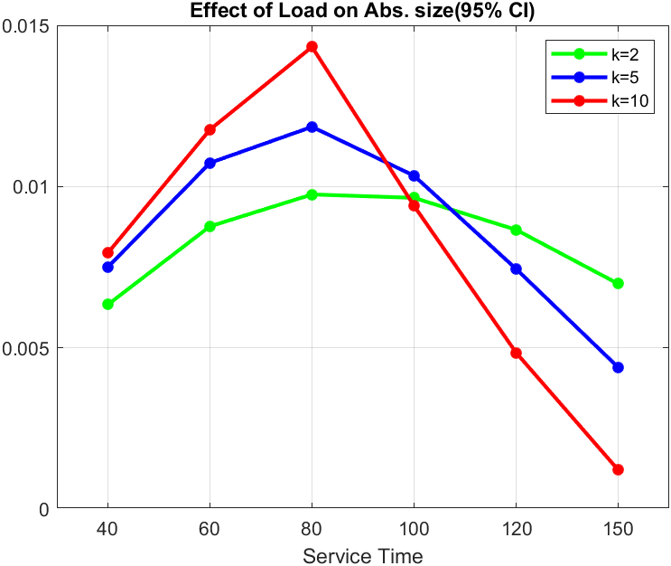

Figure 8.1

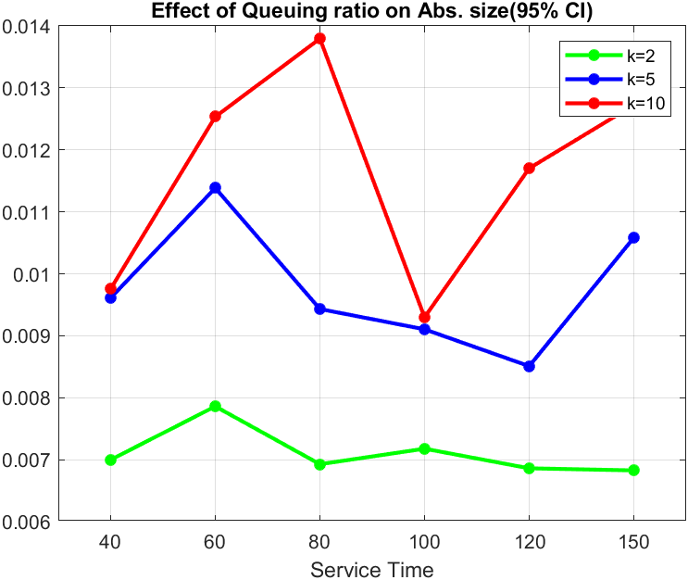

Figure 8.2

*Conclusion:* From Figure 8.1 we can see that as service-time increases from 40 to 80 (under load) there is increase in size of absolute confidence interval but from 100-150 (over load) there is decrease. From Figure 8.2 there can be no proper conclusions can be made on size of absolute confidence interval as it is increasing as well as decreasing.

**Question-9:** Comment on the impact of the size of the loss ratio on the relative sizes of the confidence intervals.

*Hypothesis:* It is assumed that as the service time increases and queue length increases size of loss ratio on relative sizes of the confidence interval is supposed to decreased.

Similar simulations were made to know the effect of the loss ratio on relative sizes of the confidence interval i.e., we changed the service time and tried to find its impact. (6 different service time and 3 different queue lengths are considered)

|  |  |  |  |
| --- | --- | --- | --- |
| System | Queue length | E[Ta] | E[Ts] |
| M/M/1 | 2 | 100 | 40 |
| M/M/1 | 2 | 100 | 60 |
| M/M/1 | 2 | 100 | 80 |
| M/M/1 | 2 | 100 | 100 |
| M/M/1 | 2 | 100 | 120 |
| M/M/1 | 2 | 100 | 150 |

Table 9.1

|  |  |  |  |
| --- | --- | --- | --- |
| System | Queue Length | E[Ta] | E[Ts] |
| M/M/1 | 5 | 100 | 40 |
| M/M/1 | 5 | 100 | 60 |
| M/M/1 | 5 | 100 | 80 |
| M/M/1 | 5 | 100 | 100 |
| M/M/1 | 5 | 100 | 120 |
| M/M/1 | 5 | 100 | 150 |

Table 9.2

|  |  |  |  |
| --- | --- | --- | --- |
| System | Queue Length | E[Ta] | E[Ts] |
| M/M/1 | 10 | 100 | 40 |
| M/M/1 | 10 | 100 | 60 |
| M/M/1 | 10 | 100 | 80 |
| M/M/1 | 10 | 100 | 100 |
| M/M/1 | 10 | 100 | 120 |
| M/M/1 | 10 | 100 | 150 |

Table 9.3

To calculate the relative half size of the confidence interval the formula is:

x 100

The table for 3 different queue-lengths and varying service-time are as follows:

|  |  |  |  |  |  |
| --- | --- | --- | --- | --- | --- |
| Service time | Queue-length | Mean | Rel 90% CI | Rel 95% CI | Rel 99% CI |
| 40 | 2 | 0.0360 | 0.1536 | 0.1833 | 0.2417 |
| 60 | 2 | 0.1034 | 0.1012 | 0.1208 | 0.1593 |
| 80 | 2 | 0.1782 | 0.0765 | 0.0913 | 0.1204 |
| 100 | 2 | 0.2513 | 0.0602 | 0.0718 | 0.0948 |
| 120 | 2 | 0.3280 | 0.0476 | 0.0568 | 0.0749 |
| 150 | 2 | 0.4234 | 0.0384 | 0.0458 | 0.0605 |

Table 9.4

|  |  |  |  |  |  |
| --- | --- | --- | --- | --- | --- |
| Service time | Queue-length | Mean | Rel 90% CI | Rel 95% CI | Rel 99% CI |
| 40 | 5 | 0.0021 | 0.8024 | 0.9575 | 1.2629 |
| 60 | 5 | 0.0232 | 0.2579 | 0.3078 | 0.4059 |
| 80 | 5 | 0.0636 | 0.1894 | 0.2260 | 0.2981 |
| 100 | 5 | 0.1440 | 0.1194 | 0.1425 | 0.1879 |
| 120 | 5 | 0.2226 | 0.0802 | 0.0957 | 0.1262 |
| 150 | 5 | 0.3490 | 0.0578 | 0.0690 | 0.0910 |

Table 9.5

|  |  |  |  |  |  |
| --- | --- | --- | --- | --- | --- |
| Service time | Queue-length | Mean | Rel 90% CI | Rel 95% CI | Rel 99% CI |
| 40 | 10 | 0 | 0 | 0 | 0 |
| 60 | 10 | 0.0012 | 1.0250 | 1.2231 | 1.6131 |
| 80 | 10 | 0.0167 | 0.4657 | 0.5557 | 0.7329 |
| 100 | 10 | 0.0856 | 0.2038 | 0.2432 | 0.3208 |
| 120 | 10 | 0.1826 | 0.1211 | 0.1445 | 0.1906 |
| 150 | 10 | 0.3381 | 0.0655 | 0.0782 | 0.1031 |

Table 9.6

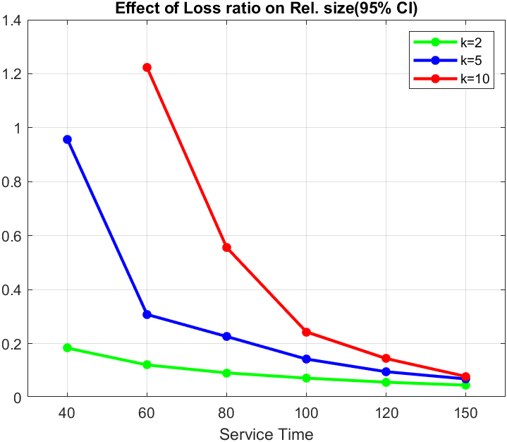

Figure 9.1

*Conclusion:* Figure 9.1 tells us about the relative size of CI and comparing results from Q7 we can say that when service time increases the absolute size of the confidence interval increases while the relative size of the confidence interval decreases and this is validated by the formula since we are dividing the size of CI by mean. If service is more the loss ratio is also more due to more waiting time, and when divided by its mean which is a higher value, we get a comparatively lower value for a relative confidence interval.

**Question-10:** Comment on the impact of the size of the load or queuing ratio on the relative sizes of the confidence intervals.

*Hypothesis:* As service-time and queue-length increases effect on relative sizes of confidence interval of load and queuing ratio are supposed to decrease.

We have simulated 6 different service-times and 3 different queue-lengths to know their impact on the size of the confidence interval:

|  |  |  |  |
| --- | --- | --- | --- |
| System | Queue length | E[Ta] | E[Ts] |
| M/M/1 | 2 | 100 | 40 |
| M/M/1 | 2 | 100 | 60 |
| M/M/1 | 2 | 100 | 80 |
| M/M/1 | 2 | 100 | 100 |
| M/M/1 | 2 | 100 | 120 |
| M/M/1 | 2 | 100 | 150 |

Table 10.1

|  |  |  |  |
| --- | --- | --- | --- |
| System | Queue Length | E[Ta] | E[Ts] |
| M/M/1 | 5 | 100 | 40 |
| M/M/1 | 5 | 100 | 60 |
| M/M/1 | 5 | 100 | 80 |
| M/M/1 | 5 | 100 | 100 |
| M/M/1 | 5 | 100 | 120 |
| M/M/1 | 5 | 100 | 150 |

Table 10.2

|  |  |  |  |
| --- | --- | --- | --- |
| System | Queue Length | E[Ta] | E[Ts] |
| M/M/1 | 10 | 100 | 40 |
| M/M/1 | 10 | 100 | 60 |
| M/M/1 | 10 | 100 | 80 |
| M/M/1 | 10 | 100 | 100 |
| M/M/1 | 10 | 100 | 120 |
| M/M/1 | 10 | 100 | 150 |

Table 10.3

The following results have been obtained upon the simulation:

1. Impact of the absolute confidence interval on load by varying service time:

|  |  |  |  |  |  |
| --- | --- | --- | --- | --- | --- |
| Service time | Queue-length | Mean | Rel 90% CI | Rel 95% CI | Rel 99% CI |
| 40 | 2 | 0.3826 | 0.0278 | 0.0331 | 0.0437 |
| 60 | 2 | 0.5463 | 0.0269 | 0.0221 | 0.0423 |
| 80 | 2 | 0.6720 | 0.0243 | 0.0290 | 0.0383 |
| 100 | 2 | 0.7558 | 0.0214 | 0.0255 | 0.0337 |
| 120 | 2 | 0.8236 | 0.0176 | 0.0210 | 0.0277 |
| 150 | 2 | 0.8832 | 0.0133 | 0.0158 | 0.0209 |

Table 10.4

|  |  |  |  |  |  |
| --- | --- | --- | --- | --- | --- |
| Service time | Queue-length | Mean | Rel 90% CI | Rel 95% CI | Rel 99% CI |
| 40 | 5 | 0.3925 | 0.0320 | 0.0382 | 0.0504 |
| 60 | 5 | 0.5980 | 0.0301 | 0.0359 | 0.0474 |
| 80 | 5 | 0.7454 | 0.0266 | 0.0318 | 0.0419 |
| 100 | 5 | 0.8552 | 0.0203 | 0.0242 | 0.0319 |
| 120 | 5 | 0.9193 | 0.0136 | 0.0162 | 0.0214 |
| 150 | 5 | 0.9722 | 0.0076 | 0.0090 | 0.0119 |

Table 10.5

|  |  |  |  |  |  |
| --- | --- | --- | --- | --- | --- |
| Service time | Queue-length | Mean | Rel 90% CI | Rel 95% CI | Rel 99% CI |
| 40 | 10 | 0.4002 | 0.0333 | 0.0397 | 0.0523 |
| 60 | 10 | 0.6088 | 0.0324 | 0.0387 | 0.0510 |
| 80 | 10 | 0.7879 | 0.0305 | 0.0364 | 0.0481 |
| 100 | 10 | 0.9144 | 0.0172 | 0.0206 | 0.0271 |
| 120 | 10 | 0.9804 | 0.0083 | 0.0099 | 0.0130 |
| 150 | 10 | 0.9974 | 0.0020 | 0.0024 | 0.0032 |

Table 10.6

2. Impact of the absolute confidence interval on queueing ratio by varying service time:

|  |  |  |  |  |  |
| --- | --- | --- | --- | --- | --- |
| Service time | Queue-length | Mean | Rel 90% CI | Rel 95% CI | Rel 99% CI |
| 40 | 2 | 0.3418 | 0.0343 | 0.0409 | 0.0540 |
| 60 | 2 | 0.4384 | 0.0300 | 0.0359 | 0.0473 |
| 80 | 2 | 0.4942 | 0.0235 | 0.0280 | 0.0370 |
| 100 | 2 | 0.5023 | 0.0239 | 0.0286 | 0.0377 |
| 120 | 2 | 0.4914 | 0.0234 | 0.0279 | 0.0368 |
| 150 | 2 | 0.4602 | 0.0249 | 0.0297 | 0.391 |

Table 10.7

|  |  |  |  |  |  |
| --- | --- | --- | --- | --- | --- |
| Service time | Queue-length | Mean | Rel 90% CI | Rel 95% CI | Rel 99% CI |
| 40 | 5 | 0.3866 | 0.0417 | 0.0497 | 0.0656 |
| 60 | 5 | 0.5695 | 0.0335 | 0.0400 | 0.0527 |
| 80 | 5 | 0.6776 | 0.0233 | 0.0278 | 0.0367 |
| 100 | 5 | 0.7058 | 0.0216 | 0.0258 | 0.0340 |
| 120 | 5 | 0.6959 | 0.0205 | 0.0245 | 0.0323 |
| 150 | 5 | 0.6217 | 0.0285 | 0.0340 | 0.0449 |

Table 10.8

|  |  |  |  |  |  |
| --- | --- | --- | --- | --- | --- |
| Service time | Queue-length | Mean | Rel 90% CI | Rel 95% CI | Rel 99% CI |
| 40 | 10 | 0.3940 | 0.0415 | 0.0495 | 0.0653 |
| 60 | 10 | 0.6044 | 0.0348 | 0.0415 | 0.0547 |
| 80 | 10 | 0.7598 | 0.0304 | 0.0363 | 0.0479 |
| 100 | 10 | 0.8269 | 0.0188 | 0.0225 | 0.0297 |
| 120 | 10 | 0.7961 | 0.0246 | 0.0294 | 0.0388 |
| 150 | 10 | 0.6591 | 0.0324 | 0.0386 | 0.0509 |

Table 10.9

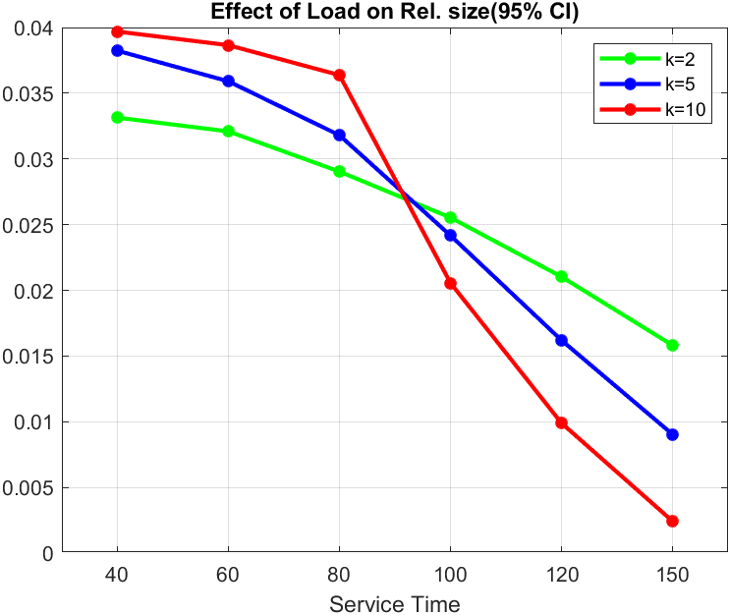

Figure 10.1

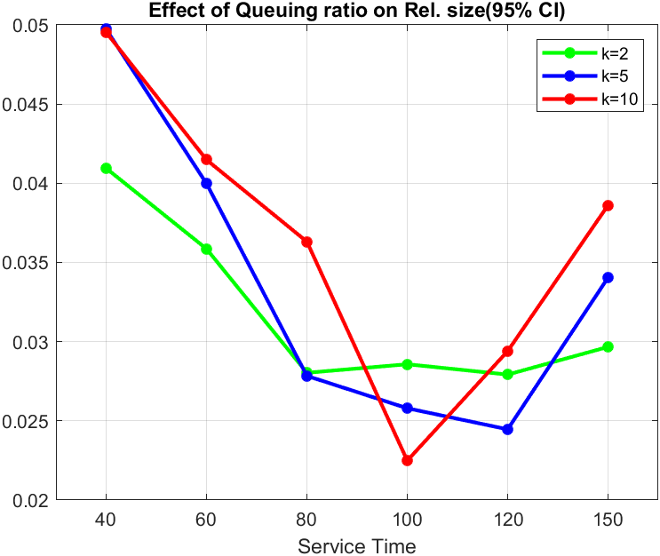

Figure 10.2

*Conclusion:* The results obtained are exactly opposite to the one obtained in Q8. Figure 10.1 shows that our hypothesis is correct while from Figure 10.2 till service time 100 there is a decrease there after we see an increase in the relative confidence size.

**Question-11:** Validate the f2 rule-of-thumb.

*Hypothesis:* "𝑓 rule-of-thumb” states that reduction of the Confidence interval by factor ‘f’ means 𝑓 the effort.

To validate the above statement, we have calculated the Confidence interval size for reference simulation parameters. We initially find out the confidence interval size for the number of batches = 200 and found it to be 0.0287 (95% CI) and wished to decrease it by a factor of 2 (f=2) and hence to see the effect on the confidence interval we have multiplied the number of batches by 4 (𝑓), so the new number of batches is 200*4 = 800. Similarly, we have considered to reduce CI by factor of 3 meaning 200*9=1800 batches and later increase CI by a factor of 2 meaning we will need 200*(1/4) = 50 batches.

We have even changed the queue-size(‘K’) to validate the effect.

The results obtained are:

|  |  |  |  |  |  |  |  |  |  |
| --- | --- | --- | --- | --- | --- | --- | --- | --- | --- |
| Number of batches | Factor(f) | Mean | | 90% CI | | 95% CI | | 99% CI | |
| K=5 | K=10 | K=5 | K=10 | K=5 | K=10 | K=5 | K=10 |
| 50 | ½ | 0.756 | 0.822 | 0.035 | 0.049 | 0.043 | 0.059 | 0.057 | 0.079 |
| 200 | 1 | 0.745 | 0.788 | 0.019 | 0.024 | 0.023 | 0.028 | 0.031 | 0.037 |
| 800 | 2 | 0.752 | 0.793 | 0.009 | 0.011 | 0.011 | 0.013 | 0.014 | 0.017 |
| 1800 | 3 | 0.751 | 0.791 | 0.006 | 0.007 | 0.007 | 0.009 | 0.009 | 0.011 |

# Table 11.1

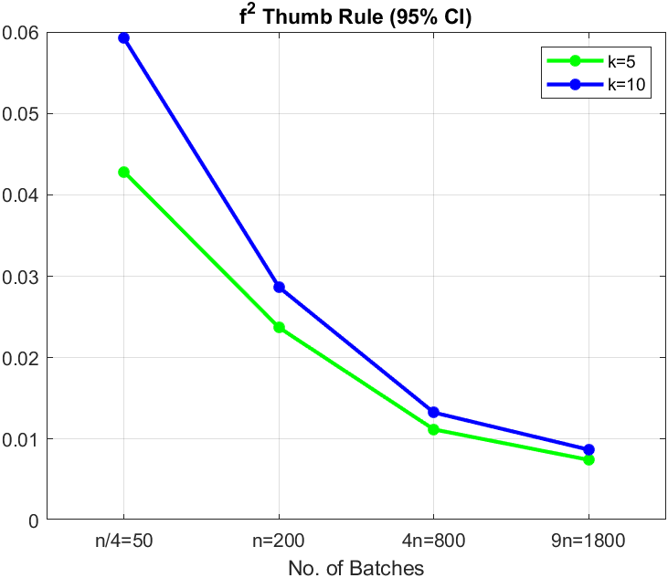

Figure 11

*Conclusion:* From the above table and Figure 11, we can validate the use of "𝑓 rule-of-thumb”.

**Question-12:** Compare loss ratio, queuing ratio, and load in the following cases:

a)- K = 0; b)- K = 2; c)- K = 10.

*Hypothesis:* With increase in queue length, it is assumed that load and queuing ratio will increase while loss ratio is supposed to decrease.

In this, we will change the queue length and plot mean values. K=0 indicates that there is no queue and hence the person who comes will be directly rejected if there is any ongoing service, we assume that the loss ratio will be relatively high for the K=0 case compared to rest two cases.

As for the load and queuing ratio we assume will increase as the K increases as there will be the effect of customers waiting in the queue on the delay of customers in queue and load on the system.

We are varying for 4 cases of queue-length, and the simulated values are as follows:

For load:

For queue length = 0:

|  |  |  |  |  |  |
| --- | --- | --- | --- | --- | --- |
| E[Ts] | Mean | Auto-Correlation | Confidence Interval | | |
| 90% | 95% | 99% |
| 60 | 0.3772 | 0.0125 | 0.0049 | 0.0059 | 0.0078 |
| 80 | 0.4439 | -0.0869 | 0.0056 | 0.0067 | 0.0088 |
| 100 | 0.4995 | -0.0408 | 0.0060 | 0.0071 | 0.0094 |
| 120 | 0.5475 | -0.0863 | 0.0059 | 0.0070 | 0.0092 |

Table 12.1

For queue length = 2:

|  |  |  |  |  |  |
| --- | --- | --- | --- | --- | --- |
| E[Ts] | Mean | Auto-Correlation | Confidence Interval | | |
| 90% | 95% | 99% |
| 60 | 0.5463 | -0.0711 | 0.0073 | 0.0088 | 0.0116 |
| 80 | 0.6720 | -0.0273 | 0.0082 | 0.0098 | 0.0129 |
| 100 | 0.7558 | -0.0290 | 0.0081 | 0.0096 | 0.0127 |
| 120 | 0.8236 | 0.0202 | 0.0073 | 0.0087 | 0.0114 |

Table 12.2

For queue length = 5:

|  |  |  |  |  |  |
| --- | --- | --- | --- | --- | --- |
| E[Ts] | Mean | Auto-Correlation | Confidence Interval | | |
| 90% | 95% | 99% |
| 60 | 0.5980 | 0.1371 | 0.0090 | 0.0107 | 0.0142 |
| 80 | 0.7454 | 0.0583 | 0.0099 | 0.0119 | 0.0156 |
| 100 | 0.8552 | -0.0152 | 0.0087 | 0.0103 | 0.0136 |
| 120 | 0.9193 | -0.0194 | 0.0062 | 0.0074 | 0.0098 |

Table 12.3

For queue length = 10:

|  |  |  |  |  |  |
| --- | --- | --- | --- | --- | --- |
| E[Ts] | Mean | Auto-Correlation | Confidence Interval | | |
| 90% | 95% | 99% |
| 60 | 0.6088 | -0.0979 | 0.0099 | 0.0118 | 0.0155 |
| 80 | 0.7879 | 0.1655 | 0.0120 | 0.0143 | 0.0189 |
| 100 | 0.9144 | 0.0605 | 0.0079 | 0.0094 | 0.0124 |
| 120 | 0.9804 | 0.0621 | 0.0041 | 0.0048 | 0.0064 |

Table 12.4

For loss-ratio:

For queue length = 0:

|  |  |  |  |  |  |
| --- | --- | --- | --- | --- | --- |
| E[Ts] | Auto-Correlation | Mean | Confidence Interval | | |
| 90% | 95% | 99% |
| 60 | 0.0658 | 0.3717 | 0.0055 | 0.0065 | 0.0086 |
| 80 | 0.0088 | 0.4423 | 0.0056 | 0.0067 | 0.0088 |
| 100 | -0.0287 | 0.4987 | 0.0058 | 0.0070 | 0.0092 |
| 120 | -0.1058 | 0.5466 | 0.0056 | 0.0067 | 0.0089 |

Table 12.5

For queue length = 2:

|  |  |  |  |  |  |
| --- | --- | --- | --- | --- | --- |
| E[Ts] | Auto-Correlation | Mean | Confidence Interval | | |
| 90% | 95% | 99% |
| 60 | -0.1392 | 0.1034 | 0.0052 | 0.0062 | 0.0082 |
| 80 | 0.1176 | 0.1782 | 0.0068 | 0.0081 | 0.0107 |
| 100 | -0.0283 | 0.2513 | 0.0076 | 0.0090 | 0.0119 |
| 120 | -0.0715 | 0.3280 | 0.0078 | 0.0093 | 0.0123 |

Table 12.6

For queue length = 5:

|  |  |  |  |  |  |
| --- | --- | --- | --- | --- | --- |
| E[Ts] | Auto-Correlation | Mean | Confidence Interval | | |
| 90% | 95% | 99% |
| 60 | 0.0467 | 0.0232 | 0.0030 | 0.0036 | 0.0047 |
| 80 | 0.0989 | 0.0636 | 0.0060 | 0.0072 | 0.0095 |
| 100 | -0.0604 | 0.1440 | 0.0086 | 0.0103 | 0.0135 |
| 120 | -0.0047 | 0.2226 | 0.0089 | 0.0106 | 0.0140 |

Table 12.7

For queue length =10:

|  |  |  |  |  |  |
| --- | --- | --- | --- | --- | --- |
| E[Ts] | Auto-Correlation | Mean | Confidence Interval | | |
| 90% | 95% | 99% |
| 60 | 0.0063 | 0.0012 | 0.0006 | 0.0007 | 0.0010 |
| 80 | 0.1679 | 0.0167 | 0.0039 | 0.0046 | 0.0061 |
| 100 | 0.0060 | 0.0856 | 0.0087 | 0.0104 | 0.0137 |
| 120 | 0.2598 | 0.1826 | 0.0111 | 0.0132 | 0.0174 |

Table 12.8

For queuing-ratio:

For queue length = 0:

|  |  |  |  |  |  |
| --- | --- | --- | --- | --- | --- |
| E[Ts] | Auto-Correlation | Mean | Confidence Interval | | |
| 90% | 95% | 99% |
| 60 | NaN | 0 | 0 | 0 | 0 |
| 80 | NaN | 0 | 0 | 0 | 0 |
| 100 | NaN | 0 | 0 | 0 | 0 |
| 120 | NaN | 0 | 0 | 0 | 0 |

Table 12.9

For queue length = 2:

|  |  |  |  |  |  |
| --- | --- | --- | --- | --- | --- |
| E[Ts] | Auto-Correlation | Mean | Confidence Interval | | |
| 90% | 95% | 99% |
| 60 | -0.1051 | 0.4384 | 0.0066 | 0.0072 | 0.0104 |
| 80 | -0.0744 | 0.4942 | 0.0058 | 0.0069 | 0.0091 |
| 100 | 0.1534 | 0.5023 | 0.0060 | 0.0072 | 0.0095 |
| 120 | -0.0863 | 0.4914 | 0.0057 | 0.0069 | 0.0090 |

Table 12.10

For queue length = 5:

|  |  |  |  |  |  |
| --- | --- | --- | --- | --- | --- |
| E[Ts] | Auto-Correlation | Mean | Confidence Interval | | |
| 90% | 95% | 99% |
| 60 | 0.0204 | 0.5695 | 0.0095 | 0.0114 | 0.0150 |
| 80 | -0.0641 | 0.6776 | 0.0079 | 0.0094 | 0.0124 |
| 100 | 0.0184 | 0.7058 | 0.0076 | 0.0091 | 0.0120 |
| 120 | -0.0759 | 0.6959 | 0.0071 | 0.0085 | 0.0112 |

Table 12.11

For queue length = 10:

|  |  |  |  |  |  |
| --- | --- | --- | --- | --- | --- |
| E[Ts] | Auto-Correlation | Mean | Confidence Interval | | |
| 90% | 95% | 99% |
| 60 | -0.1228 | 0.6044 | 0.0105 | 0.0125 | 0.0165 |
| 80 | 0.0901 | 0.7598 | 0.0116 | 0.0138 | 0.0182 |
| 100 | -0.0537 | 0.8269 | 0.0078 | 0.0093 | 0.0123 |
| 120 | 0.2814 | 0.7961 | 0.0098 | 0.0117 | 0.0154 |

Table 12.12

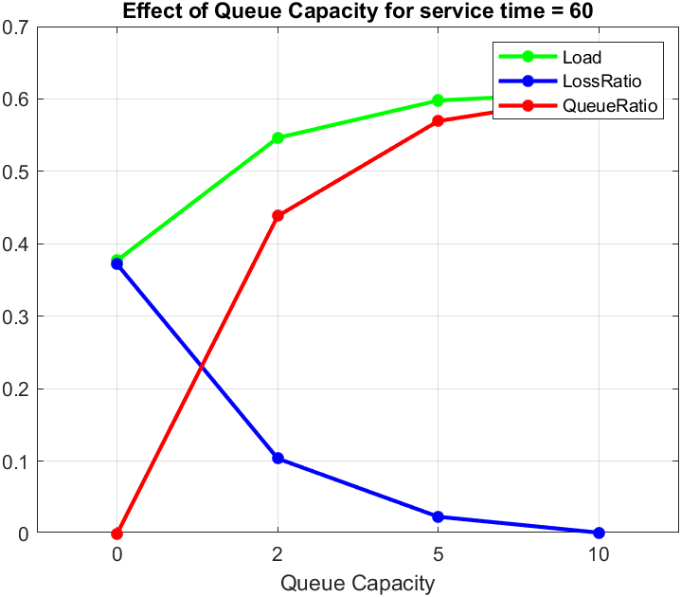 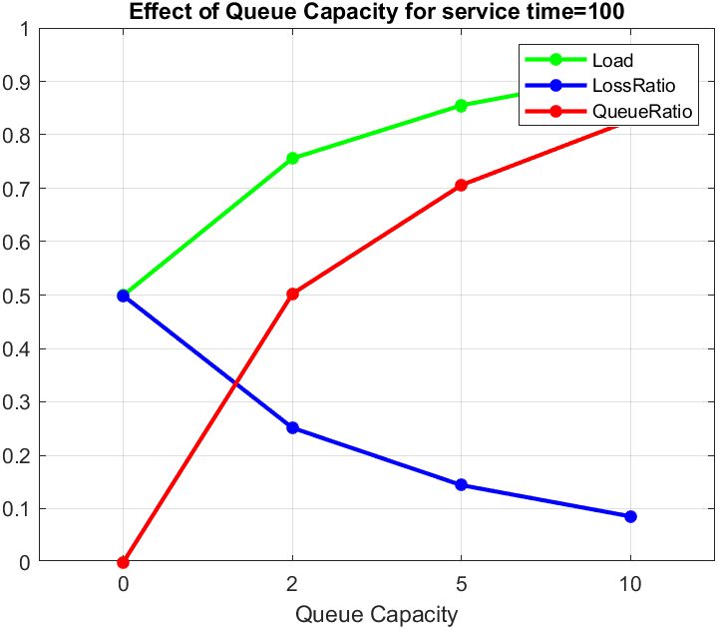

Figure 12.1 Figure 12.2

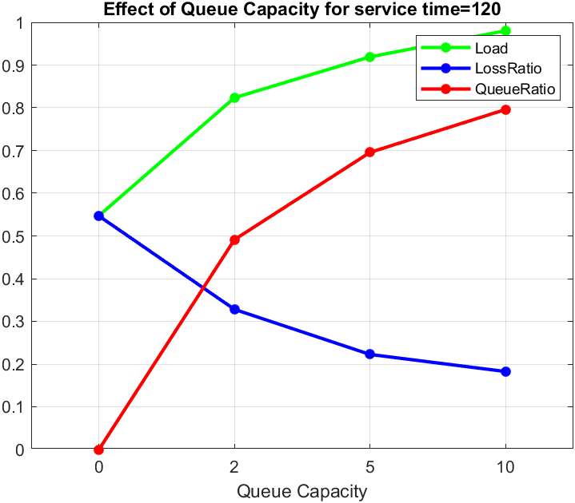

Figure 12.3

*Conclusion:* From above Figure 12.1, Figure 12.2 and Figure 12.3 we can see that as queue length increases mean value of load also increase which is same for queuing-ratio and in case of loss-ratio mean value decreases indicating more the queue length less are chances of people getting rejected.

**For the next set of questions, since the questions are on Loss Ratio & Queuing Ratio,**

**varying the queue lengths seemed more logical to observe the variations in Loss Ratio & Queuing Ratio. Also, though load is kept constant, we have tried to analyze the systems’ behaviour at underload and overload conditions, which is achieved by varying the service time.**

**Question-13:** Discuss the impact of the type of the source process (D, M, 1) and (U, M,1) on loss.

*Hypothesis:* Deterministic system should have lower loss ratios and queuing ratios compared to uniform system.

A deterministic system is a system where an initial state completely determines the system's queue states. Thus, there is no randomness in producing the future states.

We are comparing D/M/1, U/M/1 based on their Confidence interval and autocorrelation, by varying service-times and queue-lengths to check for the impact.

For queue-length = 0:

|  |  |  |  |  |  |  |  |  |  |  |
| --- | --- | --- | --- | --- | --- | --- | --- | --- | --- | --- |
| E[Ts] | D/M/1 | | | | | U/M/1 | | | | |
| Mean | Auto-Corr | 90% | 95% | 99% | Mean | Auto-Corr | 90% | 95% | 99% |
| 80 | 0.286 | 0.008 | 0.009 | 0.011 | 0.015 | 0.366 | 0.024 | 0.010 | 0.012 | 0.017 |
| 120 | 0.436 | 0.050 | 0.011 | 0.013 | 0.018 | 0.482 | 0.033 | 0.010 | 0.012 | 0.017 |

Table13.1

For queue-length = 2:

|  |  |  |  |  |  |  |  |  |  |  |
| --- | --- | --- | --- | --- | --- | --- | --- | --- | --- | --- |
| E[Ts] | D/M/1 | | | | | U/M/1 | | | | |
| Mean | Auto-Corr | 90% | 95% | 99% | Mean | Auto-Corr | 90% | 95% | 99% |
| 80 | 0.066 | 0.120 | 0.008 | 0.010 | 0.013 | 0.112 | -0.14 | 0.011 | 0.013 | 0.017 |
| 120 | 0.238 | 0.005 | 0.014 | 0.017 | 0.023 | 0.273 | 0.072 | 0.015 | 0.018 | 0.024 |

Table 13.2

For queue-length = 5:

|  |  |  |  |  |  |  |  |  |  |  |
| --- | --- | --- | --- | --- | --- | --- | --- | --- | --- | --- |
| E[Ts] | D/M/1 | | | | | U/M/1 | | | | |
| Mean | Auto-Corr | 90% | 95% | 99% | Mean | Auto-Corr | 90% | 95% | 99% |
| 80 | 0.012 | 0.072 | 0.004 | 0.005 | 0.007 | 0.029 | 0.030 | 0.007 | 0.008 | 0.011 |
| 120 | 0.182 | 0.011 | 0.016 | 0.020 | 0.026 | 0.199 | 0.047 | 0.018 | 0.021 | 0.028 |

Table 13.3

For queue-length = 10:

|  |  |  |  |  |  |  |  |  |  |  |
| --- | --- | --- | --- | --- | --- | --- | --- | --- | --- | --- |
| E[Ts] | D/M/1 | | | | | U/M/1 | | | | |
| Mean | Auto-Corr | 90% | 95% | 99% | Mean | Auto-Corr | 90% | 95% | 99% |
| 80 | 0.011 | 0.226 | 0.001 | 0.002 | 0.002 | 0.005 | -0.07 | 0.003 | 0.004 | 0.006 |
| 120 | 0.164 | 0.111 | 0.019 | 0.022 | 0.029 | 0.174 | -0.01 | 0.019 | 0.023 | 0.031 |

Table 13.4

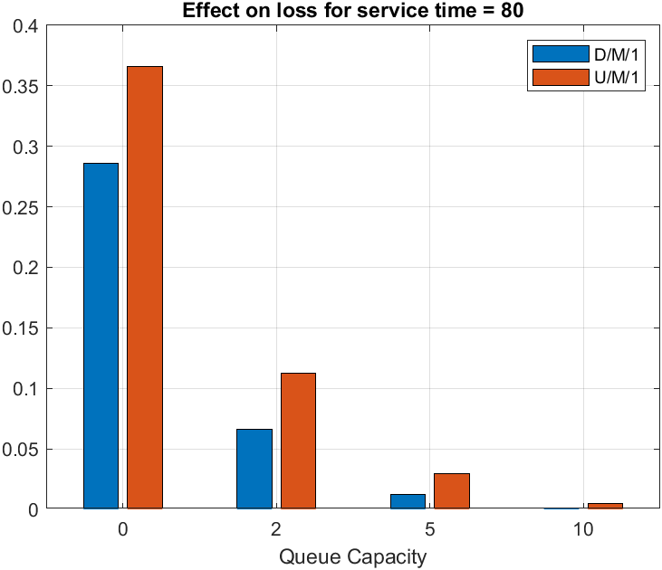 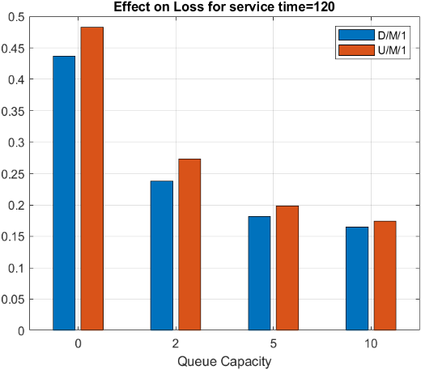

Figure 13.1 Figure 13.2

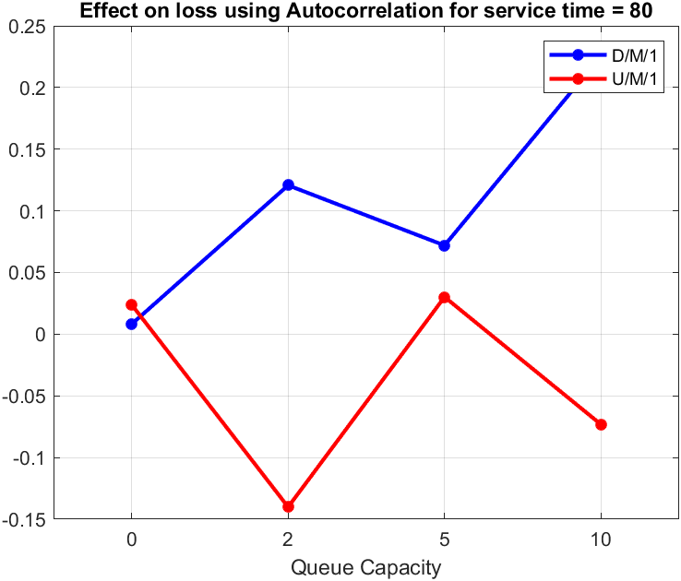 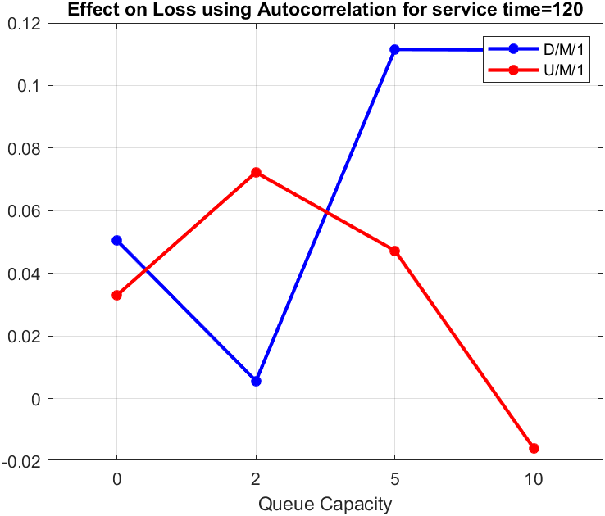

Figure 13.3 Figure 13.4

*Conclusion:* The loss-ratio tend to decrease as the queue-length increases. Uniform arrivals have randomness in them. Since deterministic arrivals are pre-determined, the losses occurring in the queue are lower than that of the uniform random arrival systems. From Figure 13.1 and Figure 13.2, we can say that mean of D/M/1 system is less than that of U/M/1 systems. The results obtained from the graph validates our predictions. It can also be concluded that with the increase of queue capacities both systems tend to converge to small values of loss ratios.

While comparing systems with respect to autocorrelation, it is expected that the deterministic systems have high autocorrelation values as they tend to have the least or no randomness. From figure 13.3 and Figure 13.4, though for initial small capacity of queues the D/M/1 & U/M/1 systems tend to show similar magnitudes, but as the queue-length increases, D/M/1 systems have higher autocorrelation compared to U/M/1 systems.

Further from above tables we can even see that as the queue-length increases the confidence interval tends to decrease for under-load case and it tends to increase for over-load case. Although the values are very small but confidence interval for D/M/1 systems is less compared to U/M/1 systems.

**Question-14:** Discuss the impact of the type of the source process (D, M, 1) and (U, M,1) on queuing ratio.

*Hypothesis:* Deterministic system should have lower loss ratios and queuing ratios compared to uniform system.

As we know a deterministic system is a system where an initial state completely determines the system's future states. Thus, there is no randomness in producing the future states.

We have compared D/M/1, U/M/1 by varying service times and queue-lengths.

For queue-length = 2:

|  |  |  |  |  |  |  |  |  |  |  |
| --- | --- | --- | --- | --- | --- | --- | --- | --- | --- | --- |
| E[Ts] | D/M/1 | | | | | U/M/1 | | | | |
| Mean | Auto-Corr | 90% | 95% | 99% | Mean | Auto-Corr | 90% | 95% | 99% |
| 80 | 0.462 | 0.128 | 0.017 | 0.020 | 0.027 | 0.418 | -0.07 | 0.013 | 0.016 | 0.021 |
| 120 | 0.576 | 0.071 | 0.013 | 0.015 | 0.020 | 0.527 | 0.003 | 0.012 | 0.015 | 0.019 |

Table 14.1

For queue-length = 5:

|  |  |  |  |  |  |  |  |  |  |  |
| --- | --- | --- | --- | --- | --- | --- | --- | --- | --- | --- |
| E[Ts] | D/M/1 | | | | | U/M/1 | | | | |
| Mean | Auto-Corr | 90% | 95% | 99% | Mean | Auto-Corr | 90% | 95% | 99% |
| 80 | 0.595 | 0.133 | 0.026 | 0.031 | 0.041 | 0.657 | 0.033 | 0.021 | 0.025 | 0.031 |
| 120 | 0.766 | 0.049 | 0.015 | 0.017 | 0.023 | 0.736 | 0.044 | 0.015 | 0.018 | 0.024 |

Table 14.2

For queue-length = 10:

|  |  |  |  |  |  |  |  |  |  |  |
| --- | --- | --- | --- | --- | --- | --- | --- | --- | --- | --- |
| E[Ts] | D/M/1 | | | | | U/M/1 | | | | |
| Mean | Auto-Corr | 90% | 95% | 99% | Mean | Auto-Corr | 90% | 95% | 99% |
| 80 | 0.621 | 0.165 | 0.030 | 0.036 | 0.047 | 0.707 | 0.068 | 0.026 | 0.031 | 0.041 |
| 120 | 0.825 | 0.076 | 0.016 | 0.019 | 0.026 | 0.813 | 0.035 | 0.017 | 0.021 | 0.028 |

Table 14.3

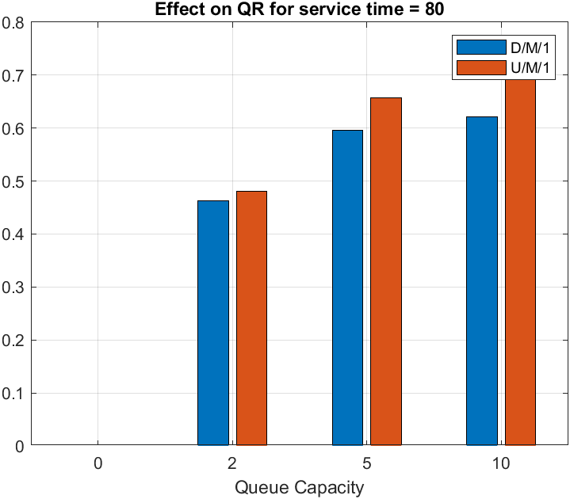 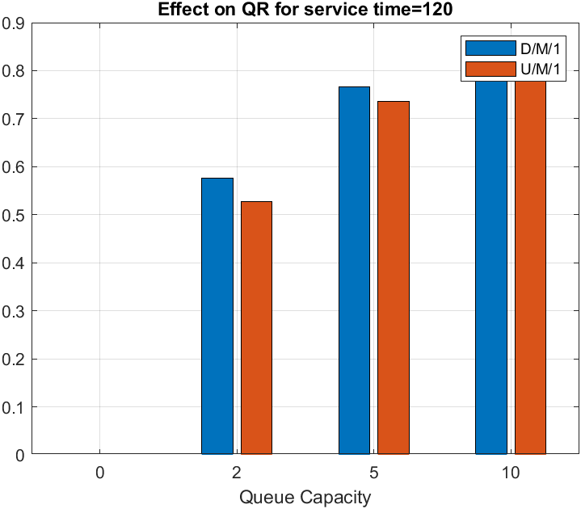

Figure 14.1 Figure 14.2

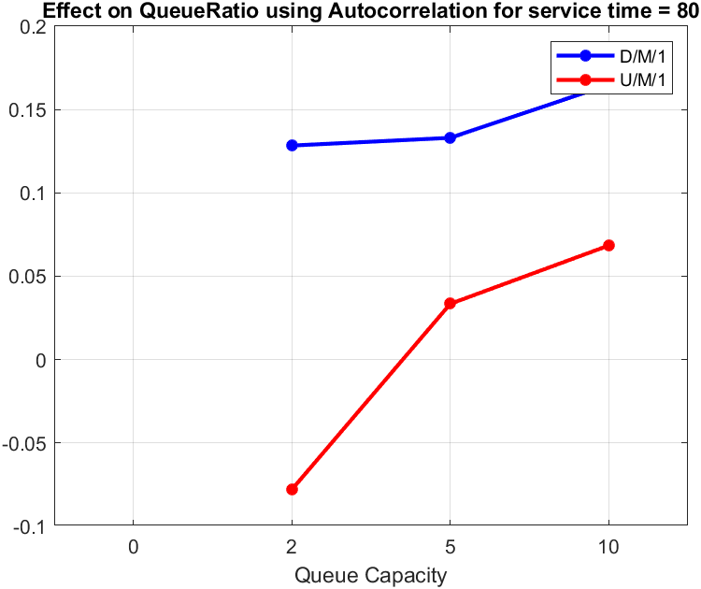 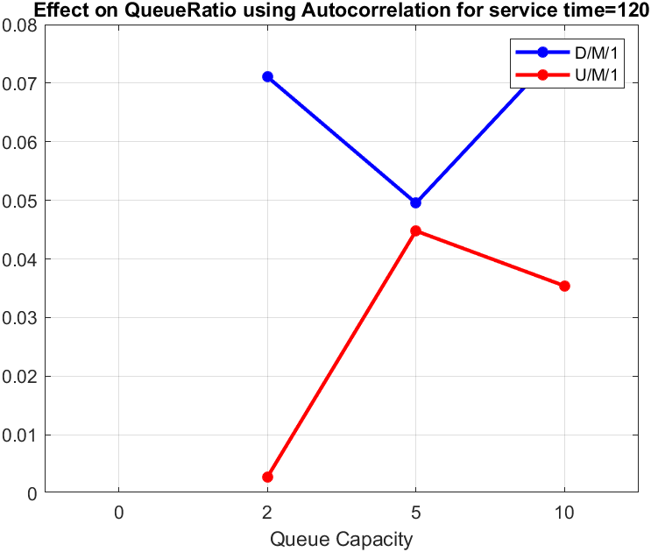

Figure 14.3 Figure 14.4

*Conclusion:*

For queue-length = 0 there is no queuing delay as any person coming will directly be rejected irrespective for source process and hence, we get ‘zero’ as their values [1]. From Figure 14.1 and Figure 14.2 we can see that as service-time changes there is shift in the properties of mean value of queuing-ratio i.e., for service-time = 80 (under load) D/M/1 has lower mean value compared to U/M/1 and exactly opposite happens for service-time = 120 (over load).

When considering autocorrelation as a parameter for comparison is it considered for any deterministic source process system to have a higher autocorrelation indicating very less randomness compared to uniform source process system. Figure 14.3 and Figure 14.4 shows auto-correlation of two systems and D/M/1 system shows higher values for autocorrelation when compared to U/M/1 and as the queue length increases the values tend to increase but after the increase also these values are very low.

From above tables we can see that when considering queueing ratio of systems with increase in queue length there is increase in the size of confidence interval values for both the systems, But, when comparing both systems U/M/1 systems have lower values of Confidence interval than D/M/1 systems for under-load case and opposite for over-load case.

**Question-15:** Discuss the impact of the type of the server process (M, D, 1) and (M, U,1) on loss.

*Hypothesis:* Deterministic system should have lower loss ratios and queuing ratios compared to uniform system.

In this question we are asked to change server process. For both the systems Confidence interval and lag-1 autocorrelation are calculated by varying service time and queue-length in order to give conclusion. Here we expect the loss ratios of Deterministic service time system to be lower than that of uniform service time system because the randomness of uniform distribution can affect the service time which may frequently fill the queue consequently making losses in the system.

For queue-length = 0:

|  |  |  |  |  |  |  |  |  |  |  |
| --- | --- | --- | --- | --- | --- | --- | --- | --- | --- | --- |
| E[Ts] | M/D/1 | | | | | M/U/1 | | | | |
| Mean | Auto-Corr | 90% | 95% | 99% | Mean | Auto-Corr | 90% | 95% | 99% |
| 80 | 0.444 | -0.13 | 0.009 | 0.011 | 0.014 | 0.446 | 0.210 | 0.01 | 0.011 | 0.015 |
| 120 | 0.545 | -0.31 | 0.008 | 0.009 | 0.012 | 0.548 | -0.05 | 0.009 | 0.010 | 0.014 |

Table15.1

For queue-length = 2:

|  |  |  |  |  |  |  |  |  |  |  |
| --- | --- | --- | --- | --- | --- | --- | --- | --- | --- | --- |
| E[Ts] | M/D/1 | | | | | M/U/1 | | | | |
| Mean | Auto-Corr | 90% | 95% | 99% | Mean | Auto-Corr | 90% | 95% | 99% |
| 80 | 0.103 | -0.03 | 0.009 | 0.011 | 0.014 | 0.137 | 0.054 | 0.010 | 0.012 | 0.016 |
| 120 | 0.255 | -0.01 | 0.012 | 0.015 | 0.019 | 0.284 | -0.05 | 0.013 | 0.016 | 0.021 |

Table 15.2

For queue-length = 5:

|  |  |  |  |  |  |  |  |  |  |  |
| --- | --- | --- | --- | --- | --- | --- | --- | --- | --- | --- |
| E[Ts] | M/D/1 | | | | | M/U/1 | | | | |
| Mean | Auto-Corr | 90% | 95% | 99% | Mean | Auto-Corr | 90% | 95% | 99% |
| 80 | 0.022 | -0.02 | 0.006 | 0.007 | 0.009 | 0.039 | 0.037 | 0.007 | 0.009 | 0.012 |
| 120 | 0.188 | 0.054 | 0.015 | 0.018 | 0.024 | 0.206 | 0.110 | 0.016 | 0.020 | 0.026 |

Table 15.3

For queue-length = 10:

|  |  |  |  |  |  |  |  |  |  |  |
| --- | --- | --- | --- | --- | --- | --- | --- | --- | --- | --- |
| E[Ts] | M/D/1 | | | | | M/U/1 | | | | |
| Mean | Auto-Corr | 90% | 95% | 99% | Mean | Auto-Corr | 90% | 95% | 99% |
| 80 | 0.003 | 0.013 | 0.002 | 0.003 | 0.004 | 0.007 | 0.113 | 0.004 | 0.005 | 0.006 |
| 120 | 0.171 | 0.082 | 0.017 | 0.021 | 0.028 | 0.175 | 0.015 | 0.019 | 0.022 | 0.029 |

Table 15.4

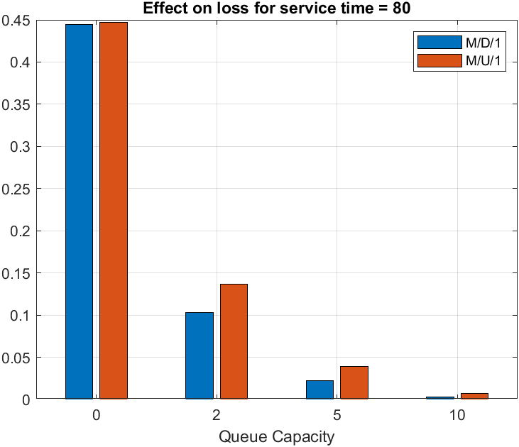 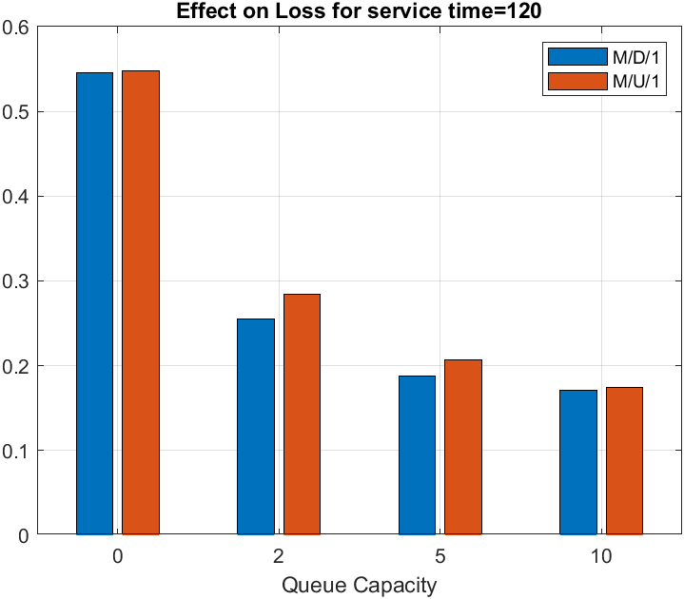

Figure 15.1 Figure 15.2

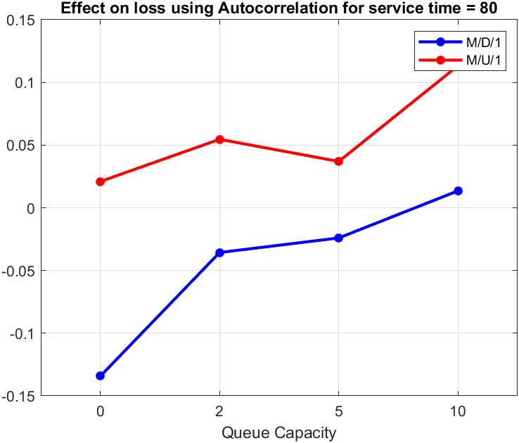 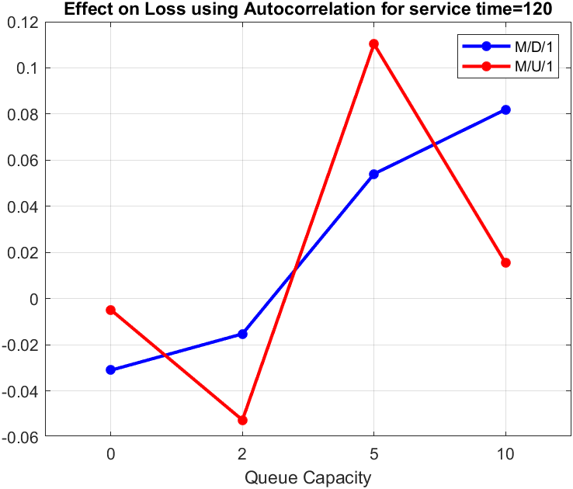

Figure 15.3 Figure 15.4

*Conclusion:*

Results are similar to that of Q13. Uniform arrivals have randomness in them. Since deterministic arrivals are pre-determined, the losses occurring in the queue are lower than that of the uniform random arrival systems. As the queue length increases loss ratio tends to decrease in both of the systems which can be seen from Figure 15.1 and Figure 15.2 irrespective of change in the loading condition.

From figure 15.3 and Figure 15.4 we see exactly opposite results to our assumption and that for M/D/1 systems we are getting very small autocorrelation, indicating a lot of randomness in the data compared to M/U/1.

As the queue length increases from tables, we can conclude that size of confidence interval tends to decrease. When comparing 2 systems size of Confidence interval is less for M/D/1 when compared to M/U/1.

**Question 16:** Discuss the impact of the type of the server process (M, D, 1) and (M, U,1) on queuing ratio.

*Hypothesis:* It is considered that deterministic system must have higher autocorrelation probably near to 1 compared to uniform systems.

For both the systems Confidence interval and lag-1 autocorrelation are calculated by varying service-time and queue-length.

For queue-length = 2:

|  |  |  |  |  |  |  |  |  |  |  |
| --- | --- | --- | --- | --- | --- | --- | --- | --- | --- | --- |
| E[Ts] | M/D/1 | | | | | M/U/1 | | | | |
| Mean | Auto-Corr | 90% | 95% | 99% | Mean | Auto-Corr | 90% | 95% | 99% |
| 80 | 0.612 | 0.164 | 0.011 | 0.013 | 0.018 | 0.567 | -0.57 | 0.011 | 0.013 | 0.017 |
| 120 | 0.639 | -0.05 | 0.010 | 0.012 | 0.016 | 0.575 | -0.47 | 0.010 | 0.012 | 0.015 |

Table 16.1

For queue-length = 5:

|  |  |  |  |  |  |  |  |  |  |  |
| --- | --- | --- | --- | --- | --- | --- | --- | --- | --- | --- |
| E[Ts] | M/D/1 | | | | | M/U/1 | | | | |
| Mean | Auto-Corr | 90% | 95% | 99% | Mean | Auto-Corr | 90% | 95% | 99% |
| 80 | 0.759 | 0.129 | 0.015 | 0.018 | 0.024 | 0.732 | -0.09 | 0.014 | 0.017 | 0.022 |
| 120 | 0.786 | 0.024 | 0.013 | 0.016 | 0.021 | 0.747 | 0.068 | 0.013 | 0.015 | 0.020 |

Table 16.2

For queue-length = 10:

|  |  |  |  |  |  |  |  |  |  |  |
| --- | --- | --- | --- | --- | --- | --- | --- | --- | --- | --- |
| E[Ts] | M/D/1 | | | | | M/U/1 | | | | |
| Mean | Auto-Corr | 90% | 95% | 99% | Mean | Auto-Corr | 90% | 95% | 99% |
| 80 | 0.795 | 0.101 | 0.018 | 0.022 | 0.030 | 0.792 | 0.026 | 0.021 | 0.025 | 0.033 |
| 120 | 0.825 | 0.081 | 0.017 | 0.020 | 0.027 | 0.814 | -0.03 | 0.017 | 0.020 | 0.027 |

Table 16.3

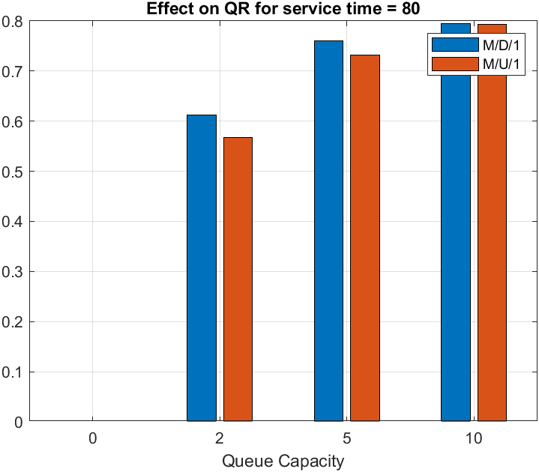 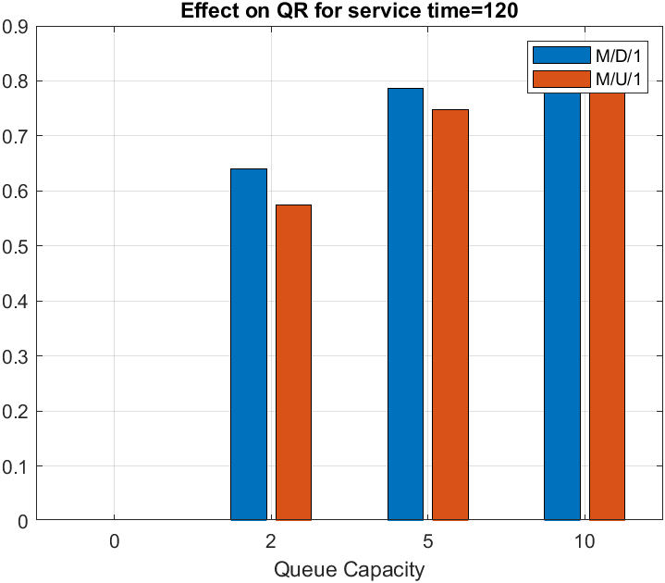

Figure 16.1 Figure 16.2

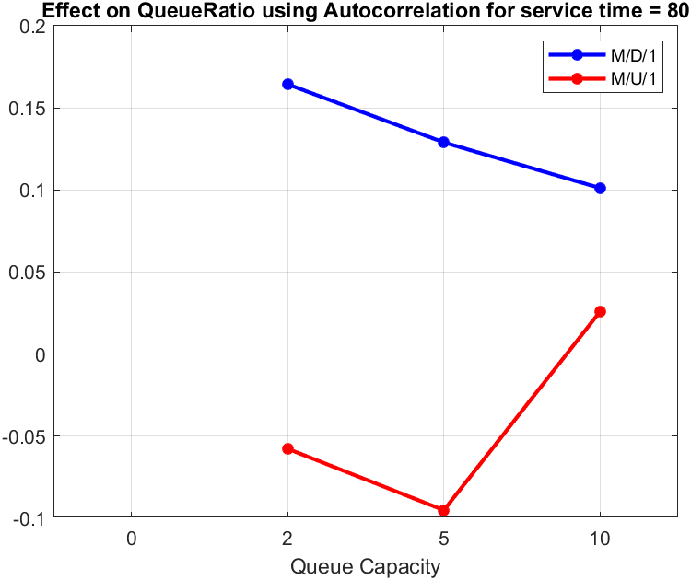 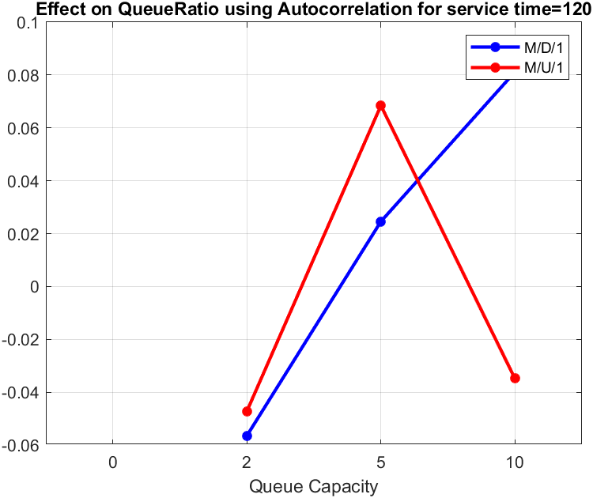

Figure 16.3 Figure 16.4

*Conclusion:* For queue-length = 0 there is no queuing delay as any person coming will directly be rejected irrespective for source process and hence, we get ‘zero’ as their values [1]. Results are similar to Q14 and we cannot see any notable difference whether we change server or source process. From Figure 16.1 and Figure 16.2 we can only see that as the queue length increases the mean of queuing ratio also increases for both the systems. From Figure 16.3 and Figure 16.4 we can see that lag-1 autocorrelation values are very small indicating presence of randomness in the data.

**Question-17:** Compare the loss ratios for the M/M/K’’=10 system with those obtained for the M/D/K’’ and D/M/K’’ systems at 80 % load and motivate your observations. (Why is the D/D/K’’ case trivial?)

*Hypothesis:* It is expected that M/D/K should have less loss ratio compared to D/M/K and M/M/K. M/M/K is expected to have more loss ratio compared to all the systems.

The simulation is first done for single-server models and then those results are used to estimate for multi-server systems.

Queue length and service times have been varied for all the systems, to find the effect on variation in loss ratio. We use Lag-1 Autocorrelation and confidence interval values to show the differences among different systems.

Here we expect the D/M/K system to have lower losses than that of M/D/K system as in the former, the deterministic arrivals tend to control how the queue states changes. Whereas in M/D/K system the arrival is completely random hence the system having deterministic service time, will have more frequently filled queue occurring the losses.

For queue length = 0 and service-time = 80:

|  |  |  |  |  |  |
| --- | --- | --- | --- | --- | --- |
| System | Mean | Auto-Correlation | Confidence Interval | | |
| 90% | 95% | 99% |
| D/M/1 | 0.2862 | 0.0082 | 0.0099 | 0.0118 | 0.0156 |
| M/D/1 | 0.4445 | -0.1343 | 0.0092 | 0.0109 | 0.0144 |
| M/M/1 | 0.4423 | 0.0088 | 0.0112 | 0.0134 | 0.0177 |

Table 17.1

For queue length = 2 and service-time = 80:

|  |  |  |  |  |  |
| --- | --- | --- | --- | --- | --- |
| System | Mean | Auto-Correlation | Confidence Interval | | |
| 90% | 95% | 99% |
| D/M/1 | 0.0659 | 0.1207 | 0.0085 | 0.0102 | 0.0134 |
| M/D/1 | 0.1033 | -0.0357 | 0.0092 | 0.0110 | 0.0145 |
| M/M/1 | 0.1782 | 0.1176 | 0.0136 | 0.0163 | 0.0215 |

Table 17.2

For queue length = 5 and service-time = 80:

|  |  |  |  |  |  |
| --- | --- | --- | --- | --- | --- |
| System | Mean | Auto-Correlation | Confidence Interval | | |
| 90% | 95% | 99% |
| D/M/1 | 0.0126 | 0.0719 | 0.0047 | 0.0144 | 0.0073 |
| M/D/1 | 0.0227 | -0.0240 | 0.0061 | 0.0073 | 0.0096 |
| M/M/1 | 0.0636 | 0.0989 | 0.0121 | 0.0055 | 0.0190 |

Table 17.3

For queue length = 10 and service-time = 80:

|  |  |  |  |  |  |
| --- | --- | --- | --- | --- | --- |
| System | Mean | Auto-Correlation | Confidence Interval | | |
| 90% | 95% | 99% |
| D/M/1 | 0.0011 | 0.2257 | 0.0016 | 0.0019 | 0.0025 |
| M/D/1 | 0.0029 | 0.0135 | 0.0025 | 0.0030 | 0.0039 |
| M/M/1 | 0.0167 | 0.1679 | 0.0078 | 0.0093 | 0.0122 |

Table 17.4

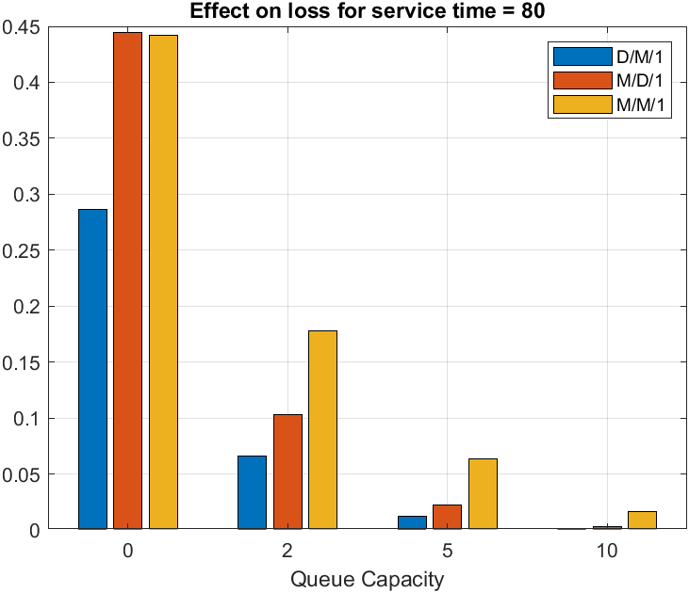 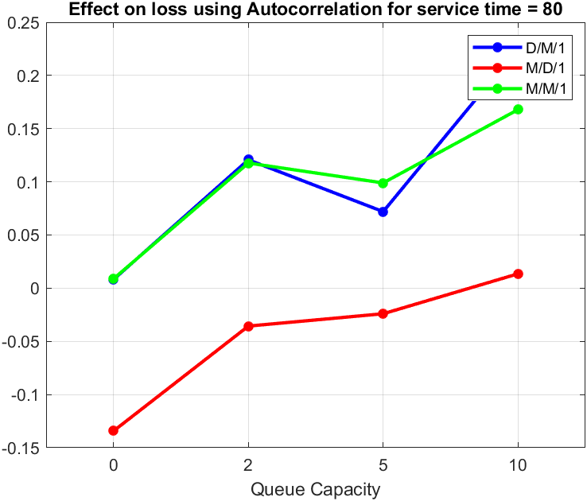

Figure 17.1 Figure 17.2

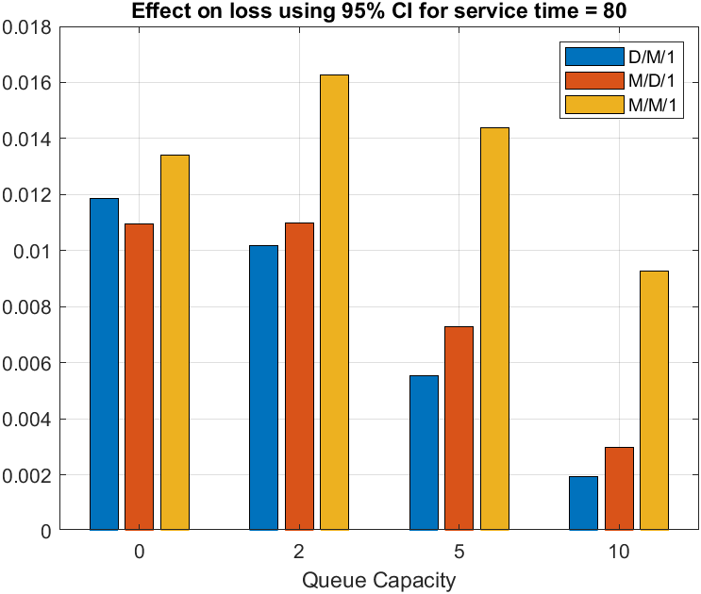

Figure 17.3

*Conclusion:* We know that for any M/M/K system there is more randomness as arrival times and service time both follow poission distribution. Hence, we can see that M/M/K systems will have more mean compared to any of the deterministic system that is M/D/1 or D/M/1 as in those systems at least one of the arrival or service time is already pre-determined and hence there is less randomness in these systems when compared to M/M/K systems. D/M/K and M/M/K tend to show similarities in values of autocorrelation as both are different only in arrival process. The negative values in M/D/K system shows opposite nature in the dataset and its Lag-1 values. M/D/K system shows more randomness.

*Why is D/D/K system trivial?*

D/D/K system doesn’t tend to have any loss or rejection. Its values remain undefined as the arrival and service times are deterministic in nature. This case is trivial because the deterministic arrival times and departure times means that they are spread out entirely evenly, and while the load is less than 100%, that means each previous arrival has always had time to depart before the next arrival. This kills the randomness of the datasets.

**Question 18:** Compare the loss ratios for the M/M/K’’ system with those obtained for the M/U/K’’, U/M/K’’ and U/U/K’’ systems at 80 % load, and motivate your observations.

*Hypothesis:* It is expected that M/M/K systems must have more loss ratio compared to U/M/K, M/U/K and U/U/K, U/U/K are supposed to have least loss ratio.

The simulation is first done for single-server models and then results are used to estimate for multi-server systems.

We have varied queue length for 4 different queues for constant service time = 80 to find the variation in loss ratio. We use Lag-1 Autocorrelation and Confidence interval values to show the differences among different systems. Our expectations is that U/U/K will have least losses and M/M/K will have most loss as the degree of randomness tends to increase gradually from U/U/k to M/M/K systems, which contribute to abrupt filling and emptying of queues. Also with increase in queue lengths we expect the variations to decrease as queue capacity increases losses should decrease. Among U/M/K and M/U/K

since the kind of arrival determines the system behaviour, we expect uniform arrival to produce lesser losses than M/U/K systems.

For queue length = 0 and service-time = 80:

|  |  |  |  |  |  |
| --- | --- | --- | --- | --- | --- |
| System | Mean | Auto-Correlation | Confidence Interval | | |
| 90% | 95% | 99% |
| U/M/1 | 0.3662 | 0.0239 | 0.0108 | 0.0129 | 0.0170 |
| M/U/1 | 0.4467 | 0.0210 | 0.0095 | 0.0113 | 0.0150 |
| U/U/1 | 0.3469 | 0.0373 | 0.0094 | 0.0112 | 0.0147 |
| M/M/1 | 0.4423 | 0.0088 | 0.0112 | 0.0134 | 0.0177 |

Table 18.1

For queue length = 2 and service-time = 80:

|  |  |  |  |  |  |
| --- | --- | --- | --- | --- | --- |
| System | Mean | Auto-Correlation | Confidence Interval | | |
| 90% | 95% | 99% |
| U/M/1 | 0.1123 | -0.1401 | 0.0111 | 0.0133 | 0.0175 |
| M/U/1 | 0.1369 | 0.0546 | 0.0102 | 0.0122 | 0.0161 |
| U/U/1 | 0.0574 | -0.0108 | 0.0070 | 0.0084 | 0.0110 |
| M/M/1 | 0.1782 | 0.1176 | 0.0136 | 0.0163 | 0.0215 |

Table 18.2

For queue length = 5 and service-time = 80:

|  |  |  |  |  |  |
| --- | --- | --- | --- | --- | --- |
| System | Mean | Auto-Correlation | Confidence Interval | | |
| 90% | 95% | 99% |
| U/M/1 | 0.0293 | 0.0302 | 0.0071 | 0.0085 | 0.0112 |
| M/U/1 | 0.0391 | 0.0369 | 0.0078 | 0.0093 | 0.0123 |
| U/U/1 | 0.0087 | 0.0851 | 0.0039 | 0.0046 | 0.0061 |
| M/M/1 | 0.0636 | 0.0989 | 0.0121 | 0.0144 | 0.0190 |

Table 18.3

For queue length = 10 and service-time = 80:

|  |  |  |  |  |  |
| --- | --- | --- | --- | --- | --- |
| System | Mean | Auto-Correlation | Confidence Interval | | |
| 90% | 95% | 99% |
| U/M/1 | 0.0052 | -0.0732 | 0.0037 | 0.0045 | 0.0059 |
| M/U/1 | 0.0073 | 0.1133 | 0.0042 | 0.0050 | 0.0067 |
| U/U/1 | 0.0006 | 0.2040 | 0.0012 | 0.0015 | 0.0019 |
| M/M/1 | 0.0167 | 0.1679 | 0.0078 | 0.0093 | 0.0122 |

Table 18.4

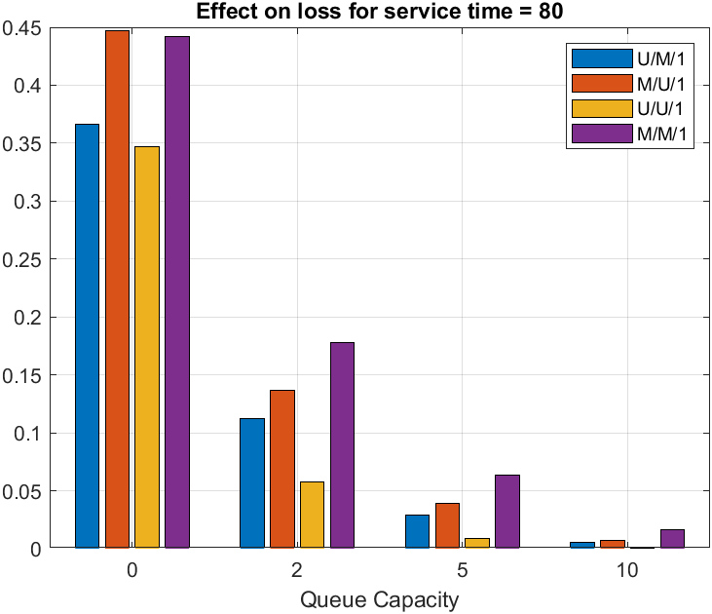

Figure 18.1

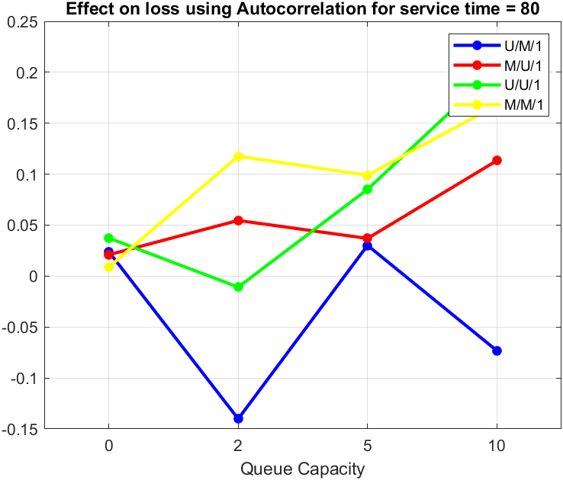

Figure 18.2

Figure 18.3

*Conclusion:*

We know that for M/M/K systems arrival and service time follow Poisson distribution hence there is more randomness in the data. In U/M/K and M/U/K there is comparatively less randomness as at least one of the parameter is uniform and for U/U/K systems both service and arrivals are uniform hence it is lowest among all. From Figure 18.1 we can see that only for queue length = 0 we get M/M/1 slightly lower than M/U/1 but in all other cases M/M/1 is higher.

When comparing autocorrelation from Figure 18.2 we can see that U/U/K system show most similar values of autocorrelation in comparison to M/U/K and U/M/K systems which are having most randomness and behave slightly opposite to each other.

From Figure 18.3 we can see that U/U/K systems have less confidence interval indicating that there is very less deviation from the mean values while M/M/K systems have highest values in all cases indicating relatively more deviation compared to others.

**Question 19:** Compare the queuing ratios for the M/M/K’’=10 system with those obtained for the M/U/K’’, U/M/K’’ and U/U/K’’ systems at 80 % load, and motivate your observations.

*Hypothesis:* It is expected that M/M/K systems must have more queuing ratio compared to U/M/K, M/U/K and U/U/K, U/U/K are supposed to have least queuing ratio.

The simulation is first done for single-server models and then results are used to estimate for multi-server systems.

We have varied queue length for 4 different queues for constant service time = 80 to find the variation in loss ratio. We use Lag-1 Autocorrelation and Confidence interval values to show the differences among different systems.

For queue length = 2 and service-time = 80:

|  |  |  |  |  |  |
| --- | --- | --- | --- | --- | --- |
| System | Mean | Auto-Correlation | Confidence Interval | | |
| 90% | 95% | 99% |
| U/M/1 | 0.4815 | -0.0779 | 0.0138 | 0.0165 | 0.0218 |
| M/U/1 | 0.5669 | -0.0577 | 0.0109 | 0.0130 | 0.0172 |
| U/U/1 | 0.5452 | 0.0290 | 0.0166 | 0.0198 | 0.0261 |
| M/M/1 | 0.4942 | -0.0744 | 0.0116 | 0.0139 | 0.0183 |

For queue length = 5 and service-time = 80:

|  |  |  |  |  |  |
| --- | --- | --- | --- | --- | --- |
| System | Mean | Auto-Correlation | Confidence Interval | | |
| 90% | 95% | 99% |
| U/M/1 | 0.6574 | 0.0335 | 0.0211 | 0.0251 | 0.0331 |
| M/U/1 | 0.7325 | -0.0951 | 0.0145 | 0.0173 | 0.0228 |
| U/U/1 | 0.6646 | -0.0059 | 0.0226 | 0.0270 | 0.0356 |
| M/M/1 | 0.6776 | -0.0641 | 0.0158 | 0.0189 | 0.0249 |

For queue length = 10 and service-time = 80:

|  |  |  |  |  |  |
| --- | --- | --- | --- | --- | --- |
| System | Mean | Auto-Correlation | Confidence Interval | | |
| 90% | 95% | 99% |
| U/M/1 | 0.7069 | 0.0648 | 0.0261 | 0.0312 | 0.0411 |
| M/U/1 | 0.7926 | 0.0259 | 0.0215 | 0.0257 | 0.0339 |
| U/U/1 | 0.6704 | 0.0856 | 0.0243 | 0.0290 | 0.0382 |
| M/M/1 | 0.7598 | 0.0901 | 0.0231 | 0.0276 | 0.0364 |

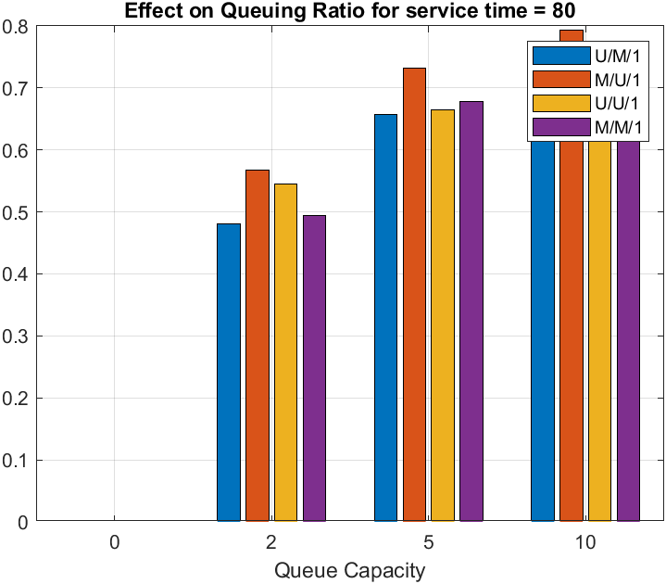

Figure 19.1

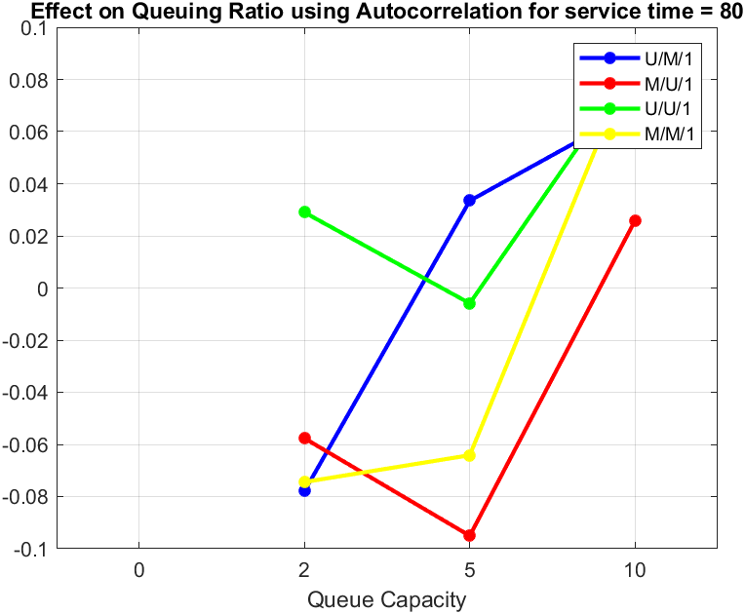

Figure 19.2

Figure 19.3

*Conclusion:*

For queue-length = 0 there is no queuing delay as any person coming will directly be rejected irrespective for source process and hence, we get ‘zero’ as their values [1] irrespective of any system. From Figure 19.1 we can see that there is effect of arrival times on the queueing ratio and hence we can see that in case of the M/U/1 systems mean value is higher when compared to M/M/1 systems.

About autocorrelation we can say that from figure 19.2 M/U/K and U/M/K show most diverse values in autocorrelation showing dissimilarities in queuing ratio. U/U/1 tend to have the most randomness in queueing values at 80% load among the other 3 systems.

We can see from Figure 19.3 that among all systems for queuing ratio we get lowest value of Confidence interval for U/M/1 system then comes M/M/1 system indicating very less deviation when compared to U/M/1 and U/U/1.

**References:**

[1]: https://www2.tkn.tu-berlin.de/teaching/rn/animations/queue/